Zou Rui
West Ukrainian National University, Ternopil
Master Student at Department for Information Computer Systems and Control

APPLICATION OF INFORMATION SECURITY TECHNOLOGY IN ENGINEERING PROJECT MANAGEMENT

In the current project management (PM) work, the implementing party can apply corresponding information security technologies (IST) to ensure the regular operation of the PM information system. The system of PM information security includes multiple subsystems, such as building information modeling (BIM) systems, enterprise resource planning (ERP) systems, and database systems.
IST is the general term for technologies related to ensuring one party's typical acquisition, transmission, processing, and application of information data while avoiding unauthorized access to and application of one party's information by others. The IST can be divided into three categories. A first category is information confidentiality technology. IST is a professional technology that uses mathematical or physical methods to protect electronic information during the transmission and storage stages to avoid data leakage. Confidential communications, computer keys, etc., are specialized ISTs. This technology is critical to ensuring data security and is typically implemented using internationally recognized security encryption algorithms. For example, the currently recognized new international cryptographic algorithm standard, Advanced Encryption Standard (AES), is a technology that uses 128, 192, and 256-bit long keys to encrypt scientifically the 128-bit long data into 128-bit ciphertext. The most significant application advantage is that it can exchange the minimum cost for the most efficient data security protection.
A second category is information confirmation technology. This professional technology avoids copying, falsifying, and adjusting data by strictly limiting the scope of information sharing. With the help of information confirmation technology, legitimate users can verify the authenticity of the data they receive, making it impossible for the sender of the information to evade the objective fact of acknowledging its transmission.
A third category is network control technology. Standard network control technologies include firewalls, audits, access control, and other technologies. Among them, firewall technology is a mature security technology that can authorize external personnel to access the network and effectively determine unauthorized personnel's access to the network, effectively ensuring online data security and scientific data circulation. Audit technology can intelligently record network device application cycles and sensitive actions and is a crucial basis for exploring system accidents. Access control technology is a technology that can determine whether a user has access rights to their database while granting multiple identity users corresponding access rights. Common network protection topology is shown in Figure 1.
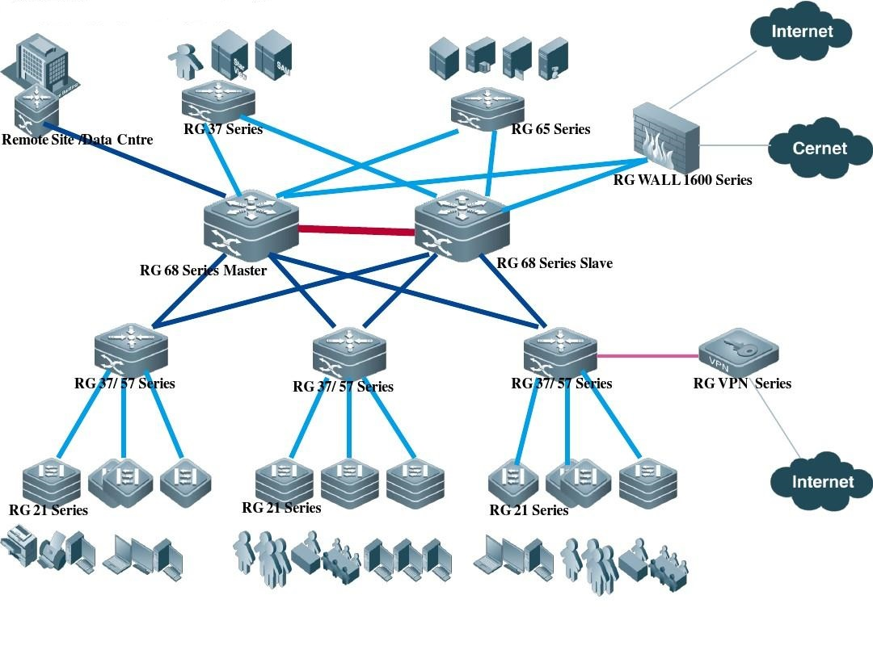
Figure 1. – Common network protection topology
Information security management and control is the core foundation for the engineering party to carry out the project. With the help of specialized IST, it can ensure the in-depth implementation of the management and control mechanism
During the implementation of an engineering project, there are quality, safety, and information management issues. Based on the above issues, the PM personnel needs to strengthen the application of IST to improve their management level effectively.
During the PM process, management personnel can use IST to ensure the safety and stability of various data and information, help the construction unit effectively collect multiple data and knowledge in the initial stage of project design, and complete the reasonable use of numerous data and information, optimizing the construction design. In addition, the construction party can also rely on IST to analyze the specific situation of the current construction. For example, in the process of information management for raw materials, some construction enterprises often rely on ERP systems. The security of internal data in ERP system can affect the efficiency of subsequent procurement and management of raw materials by construction units.
Cost management mainly refers to the management and control of the budget of the entire project during the whole construction period. During the stages of project, the PM personnel must carry out the corresponding cost management work. Cost personnel must rely on BIM technology and multiple data to evaluate and control the construction process. The IST can further ensure the security and stability of BIM database systems and digital models.
In project contract management, the application of IST by management personnel has the tremendous practical significance. The application of IST can ensure the privacy and security of relevant contract payments, such as ensuring the safety of construction technology information and production data information. The subsystem of security protection is the most fundamental part of the ICT system, and it needs to be established in project management.
In the information age, the PM personnel need to apply related IST to ensure the safety of various data information and materials during the construction and production process of the project. In the engineering PM, IST applications must be based on information and data management models. The engineering PM requires the relevant departments and institutions to establish the system of information security management and maximize the advantages of various resources. At the same time, the relevant units need to set up the multiple sub-units in the system of information security management, combined with the ERP system and BIM system. It enables to achieve the real-time and efficient transmission and sharing of various data and materials, thereby improving the quality of PM and ensuring the smooth implementation of the project.

References
- Wu Jing. Application of Computer Technology in Project Management. Enterprise Reform and Management, 2016 (4): 40.
- Ma Jianzhong, Xu Hong. Application of Information Security Technology in Project Management. Information Technology and Informatization, 2015 (3): 175-176.186.
- Liu Xue, Dong Wenna. The Application of Information Security Technology in Enterprise Management. Electronic World, 2013 (14): 193.
- A guide to the project management body of knowledge(PMBOK Guide), 2016.
- Project Management Institute. Project Management Knowledge System Guide (PMBOK Guide) [M] Beijing: Electronic Industry Press, 2018.
- 6. Li Guipeng. Application of project management in information security service projects [J]. Modern State Enterprise Research, 2018 No. 130 (04): 72-74.

