**Svetlana Zatoka**

Senior Lecturer

Phone 050 858 97 62

e-mail: zavertaluk@ukr.net

National Technical University of Ukraine "Igor Sikorsky Kyiv Polytechnic Institute"

**COMPUTER SIMULATION OF VERIFICATION**

**DIGITAL PHASE METER**

***Аnnotation***

In the summer of 2001, a description of the international project COMET (EU) focused on the development of multimedia for education in the field of measurement and metrology was presented. Information and communication technologies make it possible to effectively use both traditional and innovative means and forms of education. The use of information technology makes it possible to create distance learning for students.

Modeling of measuring equipment and software development are introduced in the creation of computer laboratory work, which allows you to get a good result. The paper considers the issue of using computer training programs in the training of metrologists at the Department of Information and Measuring Technologies of the National Technical University of Ukraine "Kyiv Polytechnic Institute. I. Sikorsky.

Verification of measuring instruments is the main element of ensuring the uniformity of measurements in the country. Computer simulation of verification of a digital phase displacement meter is considered.

In the work, a digital phase shift meter of the F2-34 type was used as a test measuring instrument, designed to measure the phase shift between two synchronized sinusoidal signals. A phase shift calibrator of the F1-4 type was used as a reference instrument. Since the basic error of the reference measuring instrument does not exceed 1/3 of the permissible basic error of the test instrument, according to the requirements of [1], it makes it possible to implement the verification method - the method of direct measurements.

he development environment LabVIEW 2015[2] was used to develop a simulation model of a phase shift meter.

Keywords: simulation model, phase shift, calibrator, reference tool, sinusoidal signal, measurement range, frequency, error

1. Statement of the problem

The task was to develop a simulation model of the investigated phase angle meter of the F2-34 type, designed to measure the phase shift between two synchronized sinusoidal signals. The input voltage range is from 2 mV to 3 V, the frequency range of the input signals is 0.2 Hz - 5 MHz, the main measurement error is ±0.01 0  and the reference measuring instrument is the phase shift calibrator of the F1-4 type, with the limits of the permissible basic error of ±0.030 at frequency 20÷104 Hz, ±0.050 at frequency 104÷106 Hz. Phase shift calibrator type F1-4, designed to reproduce phase shifts in the range 0-(±360) 0  with a resolution of 100 at 5 Hz-2 MHz.

To control the voltage of input signals, the development of a simulation model of a microvoltmeter type B3-57 and to demonstrate the phase shift between two signals, display their images on an oscilloscope.

As well as the development of appropriate software for the implementation of the verification operations of the F2-34 meter, in accordance with the requirements of L [1**].: test - control of the voltage at the inputs of the phase meter; estimation of metrological characteristics - determination of the measurement error of phase displacement at equal optimal values ​​of input voltages and at unequal values ​​of input voltages.**

Development: descriptions of the simulation model (desktop), the procedure for performing a measurement experiment, an example of testing.

2. Analysis of recent research and publications

According to the course "Testing and conformity assessment" a set of computer laboratory works (7 pieces) was developed. 8 Certificates for registration of copyrights were received. Computer program: No. 83525 [3], No. 61135 [4], No. 61136 [5], No. 64919 [6], No. 64920 [7], No. 70307 [8], No. 70308 [9], No. 82952 [10] . A number of works have been published [11,12,13]. In addition, a number of author's certificates for a software product and a number of publications in the Ukrainian Metrological Journal and collections of articles from a number of conferences were received on the course "Methods and Measuring Instruments". Work on the improvement and development of new computer works continues.

3. Purpose and task of the article

Since the mid-nineties, a lot of work has been done on the organization and implementation of distance learning at the Department of Information and Measurement Technologies of the National Technical University of Ukraine "Igor Sikorsky Kyiv Polytechnic Institute". The author of the article is engaged in the development of computer laboratory work on the courses "Methods and Measuring Instruments" and "Testing and Conformity Assessment". The purpose of the article is to familiarize foreign colleagues with the developed methodology for creating such works, presenting the results and obtaining an assessment of the work.

4. Computer simulation of verification of a digital phase meter

4.1. Introduction.

To develop a simulation model of a phase shift meter, the LabVIEW 2015 development environment was used. Program development in LabView occurs simultaneously in two windows: a block diagram and a front panel. A graphical interface of the program is created on the front panel and, in parallel, the interface is connected with the program itself, created using special blocks. Thus, the graphic code of the program has the form of a specific block diagram. The measurement system created in LabVIEW has more flexibility than the standard laboratory instrument, as it uses the variety of possibilities of modern software. And it is you, not the equipment manufacturer, who determines the functionality of the device being created. The VI consists of two main parts: - front panel (Front Panel), on which there are control knobs, buttons, graphic indicators and other controls (controls), which are means of data input from the user, and indication elements (indicators) - the source data from the program. The user enters data using the mouse and keyboard, then sees the results of the program on the monitor screen;

4.2 Verification procedure

The main error of the phase shift meter is determined by the method of comparison with an active or "passive" reference measure, or independent verification. If the error of the reference measure does not exceed 1/3 of the limit of the main permissible error of the phase meter, the main error is determined using an active measure, which is used as a phase shift calibrator or two-phase generators. In this work, a phase shift calibrator is used as a reference measure.

When testing a digital phase displacement meter, the following operations are performed:

1. Test

2. Voltage control at the inputs of the phase meter

3. Evaluation of metrological characteristics:

3.1 Determination of measurement error with equal optimal values ​​of input signals.

3.2 Determination of the measurement error with weakened and constant equal values ​​of the input signals.

3.3 Determining the measurement error when changing the level of input signals in one of the channels.

4.3. Description of the simulation model.

The simulation model of the "Desktop" is shown in Fig. 1

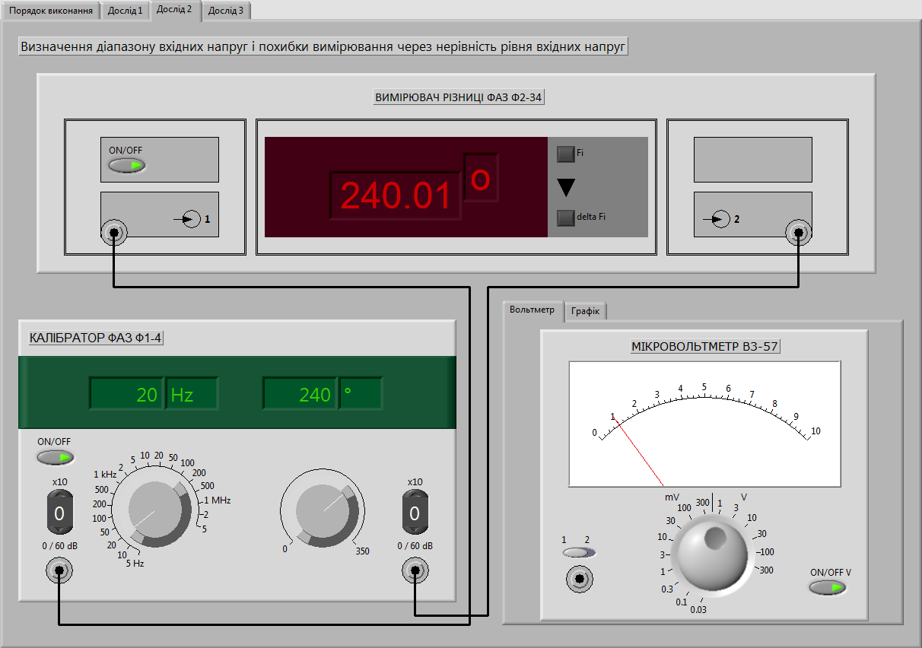

Figure 1. Simulation model of the "Desktop". Experience 1

There are three buttons on the model: "Execution order", Experience "1",

"Experiment 2", Experience "3". Models of the Phase shift angle meter type F2-34; Phase shift calibrator type B1-4; microvoltmeter V3-57.

4.4 Procedure for performing a measurement experiment

4.4.1 Enter the "Order of execution". This tab contains a window for selecting a task option and a description of the order of laboratory work..

4.4.2 Tab "Experience 1". Voltage control at the inputs of the phase meter. On the

screens is a simulation model of the desktop, Fig.1.

Check the voltage at the inputs of the phase meter using a voltmeter. The voltage control at the inputs of the phase meter is carried out at a frequency of 100 kHz, with phase shifts (9, 10, 20, 30, 240 and 350)0. Three measurements are taken at each frequency and the arithmetic mean is calculated. The ratio of input signal levels should not exceed 6 dB of the larger signal.

4.4.3 Tab Experiment 2" Determination of the basic error with equal optimal input signals. On the screen - a view of the desktop, Fig.2.

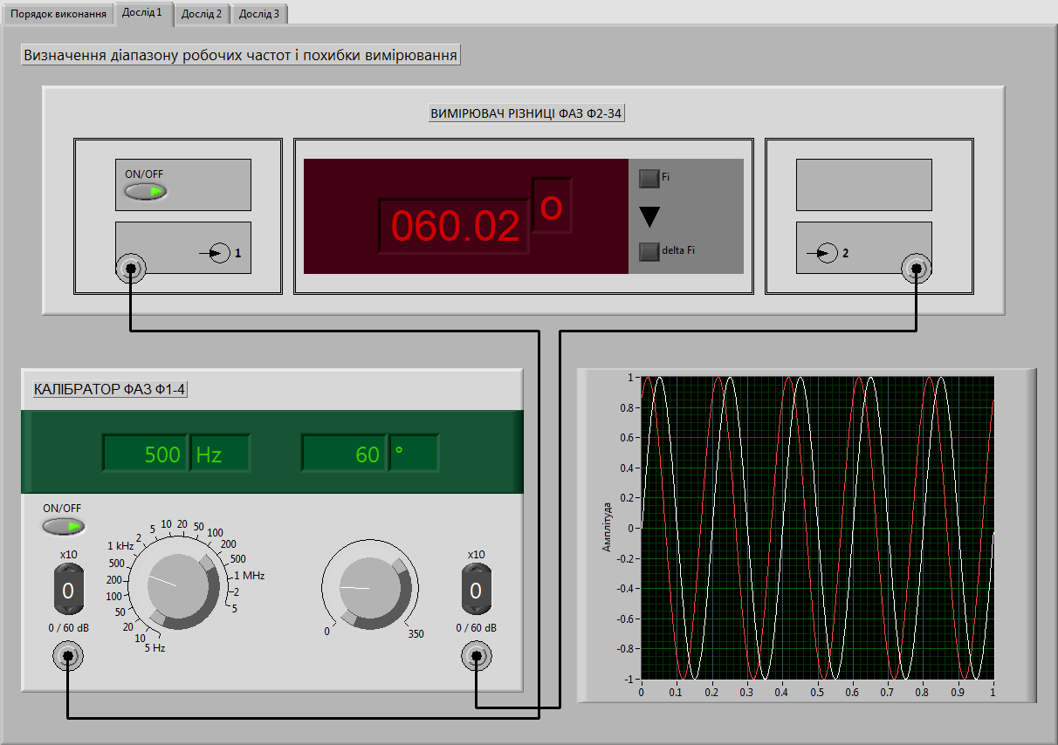

Figure 2. Simulation model of the "Desktop". Experience 3

On the desktop, instead of a microvoltmeter V3-57, a graph is presented with

visual display of the phase difference angle. The order of the experiment: - set the frequency to 20 Hz and the angle of 0° phase shift of the calibrator; - set the phase meter values ​​equal to (0±0.1) °; - Set sequentially the angles 90°, 180° and 270° of the phase shift of the calibrator and, after setting each of these angles, determine the deviations from their readings of the phase meter, taking into account its initial readings set during zeroing;

- repeat for 100 kHz and 5 MHz.

- the basic error of the phase meter is determined by the formula Δϕ = ϕФ ,

where ϕФ and ϕК are the readings of the phase meter and the indicator of the calibrator.

4.4.4 Determination of the measurement error with weakened and constant equal values ​​of the input signals.

*The order of vikonanny*

Go to the "Experience 2" tab:

- turn on the devices;

- set the frequency to 5 Hz and the angle of 0° of the phase shift of the calibrator; - on channel 2, set the signal attenuation to 20 dB; - set the phase meter readings equal to (0±0.10)°; - Set sequentially the angles 90°, 180° and 270° of the phase shift of the calibrator and determine after setting each of these angles of deviation from their displays:

- repeat for 200 kHz, 2 MHz and 5 MHz;

- on channel 2, set the signal attenuation to 40 dB and 60 dB and repeat the measurement for each attenuation value;

- perform calculations.

4.4.5 Tab "Experience 3". Determining the error when changing the level of input signals in one of the channels

The order of vikonanny

- turn on the devices;

- set the frequency to 100 kHz and the angle of 0° of the phase shift of the calibrator;

- set the zero values ​​of the phase meter with an accuracy of (0±0.10)°;

- Set sequentially every 10° the value of the phase shift of the calibrator in the range from 0° to 350° and after each of them the readings of the phase meter;

- perform data processing

4.5 Measurement result examples

4.5.1 Determining the error of the phase meter in one frequency with equal values ​​of the input signals is given in Table 1. Verifiable marks: from 0° to 360° through 10° at a frequency of 100 kHz.

Table 1

|  |  |  |
| --- | --- | --- |
| Frequency | Phase angle, 0 | Phase meter readings, 0 |
| 100 кГц | 0 | 9,16 |
| 90 | 99,98 |
| 180 | 190,06 |
| 270 | 280,41 |

4.5.2 Measurements of the phase meter error in one frequency with unequal values ​​of input signals are given in Table 2

Table 2.

|  |  |  |  |  |  |
| --- | --- | --- | --- | --- | --- |
| Frequency | Phase angle, 0 | Phase meter readings,0 at 20 dB | Phase meter readings, 0 at 40 dB | Phase meter readings, 0  при 60 дБ, 0 | |
| 5 Гц | 0 | 9,18 | 9,35 | | 10,5 |
| 90 | 100,40 | 99,43 | | 100,45 |
| 180 | 191,53 | 189,07 | | 189,83 |
| 270 | 279,81 | 279,61 | | 280,16 |

5. Conclusions and prospects for further development

The use of computer technologies in the training of specialists in the specialty "Metrology and measuring equipment" made it possible:

• to study the method of experimental determination of the metrological characteristics of the measuring equipment;

• the possibility of providing distance learning, which is used in Nowadays;

• consolidate knowledge of the course by performing independent work, using methodological materials for their implementation;

• increase the activity of studying the discipline, as team work is excluded;

• concentration of knowledge in one product, which directly used for learning;

• study the methodology and acquire the skills of checking the phase shift meter;

• creation of a unified educational space - the possibility of using these materials in the training of specialists in other specialties.

Currently, work continues on the introduction of computer technology in the educational process.

Literature

1. MI 1672-87 Guidelines. State support system

unity of measurements. Phase meters are electronic. Verification procedure

2. E.V.Sviridov, Ya.I.Listratov, N.A.Vinogradova Development of applied software in the environment. Moscow: MEI Publishing House, 2005 - 50 p.

3. Zatoka S.A. Copyright registration certificate No. 83525 Computer program Simulation of verification of a digital phase angle meter «10.12.2018.

4. Zatoka S.A. Copyright registration certificate No. 61135 Computer program “Verification of a multivalued resistance measure using a resistance comparator” 08/11/2015.

5. Zatoka S.A. Copyright registration certificate No. 61136

Computer program Experimental determination of metrological characteristics of measuring equipment” 11.08.2015

6. Zatoka S.A. Copyright registration certificate No. 64919 Computer program “Computer training program for microwebermeter verification” 04/14/2016;

7. - Zatoka S.A. Copyright registration certificate No. 64920 Computer program "Computer training program for checking an electronic voltmeter" 04/14/2016;

8. Zatoka S.A. Copyright registration certificate No. 70307 Computer program "Crypto training program for checking the inductance store" 02/07/2017;

9. Zatoka S.A. Copyright registration certificate No. 70308 Computer program "Computer training program for checking the measuring current transformer" 02/07/2017;

10. Zatoka S.A. Copyright registration certificate No. 82952 Computer program “Evaluation of the metrological characteristics of the phase shift calibrator” 11/19/2018;

11. Zatoka S.A. “The experience of creating computer training programs for metrologists”, Ukrainian Metrological Journal, 2015, No. 4, 37-41;

12. Zatoka S. Computer simulation of the calibration of measuring current transformers. Collection of articles of the 25th All-Ukrainian practical-cognitive conference "Scientific thought of modernity and the future" January 2019;

13. Zatoka S.A. Implementation of information technologies in the educational process, Collection of articles X “Trends in the development of modern scientific thought”, 1920, Vancouver, Canada