УДК 004.032.26
Yevdokymov S.
https://orcid.org/0000-0001-7213-0259
serge.evdokimov2015@proton.me
serge.evdokimov2015@gmail.com
magister
Kherson State University

Taranushchenko V.
vladimirpt50@gmail.com
autoshkolanova@gmail.com
author of the book: "Alphabet of traffic laws for everyone",
teacher of "Svitlofor" driving school, Kherson

PROSPECTS OF USING A CONVERSION NEURAL NETWORK TO PREVENT TRAFFIC ACCIDENTS IN A POPULAR POINT
Judging by the growing number of publications from companies professionally engaged in the prevention of traffic accidents and emergency situations, great importance is attached to the solution of this task. A convolutional neural network (CNN, ConvNet) is a class of forward propagation deep artificial neural networks that has been successfully applied to the analysis of visual images [1]. As part of this work, a study of the influence of various factors on the number of administrative and criminal offenses in the field of traffic was conducted.
The essence of the method proposed in the work, the method is intended for management in an emergency situation of TK. consists in the fact that after the accumulation of information about the road situation from various sources and the formation of correspondence, the classification of the situation is carried out - assigning it to the appropriate category. In order to check the efficiency of the method, the overtaking situation was simulated on a two-lane road, where overtaking is carried out with an exit to the lane of oncoming traffic. When modeling using the TensorFlow neural network, two layers of tf.keras.layers were used. Dense. Training was conducted in 5 stages (Illustration 1).
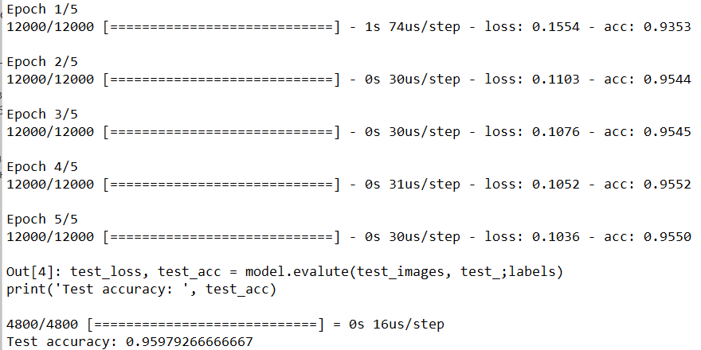
Illustration 1 – The result of the simulation of the manifestation of
emergency dangerous situations in my Python

The accuracy of recognition of an emergency situation during overtaking was approximately 0.92. Therefore, the use of a complex neural network for processing information about the traffic situation allows to detect accidents, and the integration of such an algorithm in car handling systems can save accidents [2]. Conducting an experiment showing the prospect, that opens up new possibilities for the development of smart, compact, energy-independent systems of piece intelligence. In the future, based on the data given by those, there are prospects for developing software security, within the framework of additional studies, to expand, thoroughly develop the neural network.
References:
- Cremer M., Ludwig J. A fast simulation model for traffic flow on the basis of Boolean operations // Mathematics and Computers
in Simulation. 1986. V. 28. N 4. P. 297–303. doi:
10.1016/0378-4754(86)90051-0
- Alvarez I., Poznyak A., Malo A. Urban traffic control problem via a game theory application // Proc. 46th IEEE Conference on Decision
and Control (CDC 2007). 2007. P. 2957–2961. doi:
10.1109/CDC.2007.4434820

