Ugrimova E.S., student, Department of SAIT NTU "KhPI", Kharkiv
ORCID 0009-0006-9040-7497
Azarenkov V.I., Associate Professor, Department of SAIT NTU "KhPI", Kharkiv
ORCID 0000-0001-6305-4944

DEVELOPMENT OF ADVERTISING WEB PAGES OF SITES

A new method for generating data on the example of creating advertising web pages for websites of selling companies are proposed. A website templating algorithm has been developed that makes it possible to speed up and modernize the processes of creating and publishing data, and most importantly, to avoid errors in the formation of selling pages of the site and completely abandon the long and problematic testing phase.
A landing page is a one-page website created to achieve a specific goal or implement a marketing campaign. The user gets to them from contextual advertising, blogs, banners, social networks, ads, mailing lists or search results. Each page offers one product to a specific target audience. This guarantees a high hit rate. The landing page is distinguished from other web pages by its laconic design and a minimum of text. There are no distracting ads, flashing banners, an overabundance of offers, or a pop-up menu. The design and content serve the only purpose: to call for active action in relation to the presented product or service: order, call, buy, subscribe to the newsletter. Almost everything can be promoted through a landing page: consumer goods, real estate, information products, overseas tours, various services, and much more. Landing page conversions are always higher than regular sites.
In our case, the landing page is used for a concise presentation of the product, collecting information from a potential client and subsequent sale. The development of such a web page takes a small amount of time, however, this type of site is used for a large number of goods, and this results in a large number of edits and changes in pictures, texts and information that comes with the order: product article, color, size, price, etc.. A large number of edits means a lot of errors, a lot of time spent on tests and, accordingly, on publishing a new product on the network.
In addition to these problems, it was necessary to solve the issues of convenient communication with visitors-clients in terms of launching a new product and professional design of the site page with photographs (drawings) of the product with descriptions advertising the product.
Thus, we have the following development task: it is necessary to template the site, speed up and modernize the publication, and most importantly, avoid errors and completely eradicate the long and relatively difficult testing stage, replace the advertising text with code, and then substitute the desired text instead of the code.
There are no solutions to such problems in the open publication. It was decided to try using the Angular translate module for translations. The technology is as follows: a .json file is edited - the code and text are written. Next, the .json code is substituted into the html code. using the command {{'code' | translate}} (see image below).
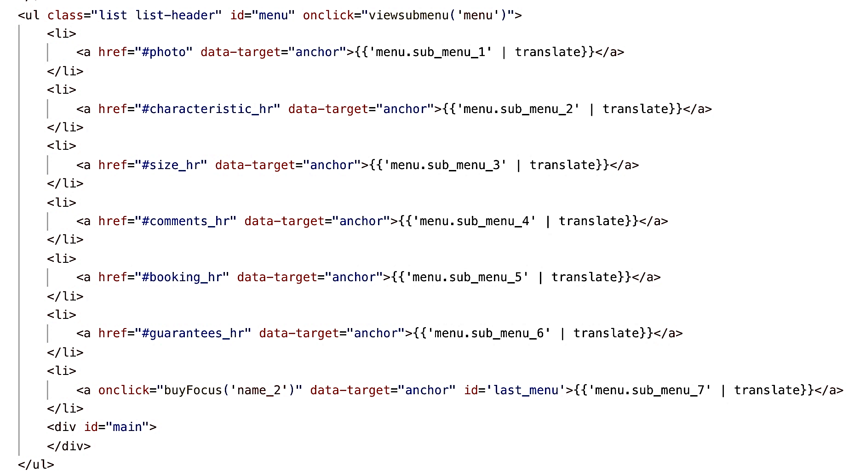
It remains to set a certain structure of local files so that the site creation algorithm looks like this:
– the .json file is copied and edited: the name of the file and the text in it are changed;
– a folder with images is copied and edited: the name of the folder is changed and substituted for the desired names, new pictures;
– the global variable is set to the new path to the newly created .json file.
It will take a little more time to create such a landing page, but later all the time spent will pay off. Thus, we have a template landing page that allows you to quickly and without errors create a web page for a new product. The great and undeniable advantage of the developed approach is that this method allows you to create a selling page even for people who do not know web programming. If we are talking about creating a specific one-page site, this method will not work, but this method is suitable for companies that sell leads. With a large number of orders, this method will increase the speed of generating a web page by 10 times.

References

1. Wikipedia (wikipedia.org). Landing page (landing page) https://uk.wikipedia.org/wiki/.
2. Ash, Tim. Landing Page Optimization: The Definitive Guide to Testing and Tuning for Conversions. — Wiley Publishing, 2011. — 384 p.

