Inna Trunova, PhD,
Olena Yakhnenko, PhD
Daryna Ruslanova
Sumy State University, Sumy

ANALYSIS OF WAYS TO REBUILD UKRAINE'S ENERGY INDUSTRY IN ACCORDANCE WITH THE ENVIRONMENTAL REQUIREMENTS OF THE EUROPEAN UNION

The issue of energy is one of the most important problems facing humanity today. The development of the country depends on the level of development of the electric power industry.
Approximately 50% of all carbon dioxide emissions on the planet come from meeting the energy needs of buildings [1].
Planning policies should help ensure climate resilience and support the supply of renewable and low-carbon energy and related infrastructure.
In 2021, the generating capacity of the national power plants of Ukraine amounted to almost 157 billion kWh, which is 5% more than in 2020 (tabl. 1).

Table 1 – Structure of electricity production [2].
Electricity  production | 2020 year |  | 2021 year
 | million kW/hour | % | million kW/hour | %
In total | 148856,2 | 100,0 | 156575,7 | 100,0
Thermal power plants | 52360,8 | 35,2 | 45834,0 | 29,3
Hydroelectric power station | 7583,9 | 5,1 | 10445,8 | 6,7
Nuclear power plants | 76202,6 | 51,2 | 86205,4 | 55,1
Renewable energy sources | 10862,0 | 8,5 | 12519,7 | 8,9

According to the results of 2021, in the energy balance of Ukraine, 69.7% of electricity was accounted for by power plants without carbon (CO2) emissions, namely hydroelectric power plants and gas power plants, nuclear power plants and renewable energy. This indicator is 6.1% higher than in 2020.
As of the end of 2021, the installed capacity of the renewable energy sector of Ukraine reached about 10,000 MW.
Wind energy is second only to solar energy in the total installed capacity of the renewable energy sector in the country, but the geography of the location of the objects falls more on the sub-regions and eastern regions of Ukraine, which are currently under the occupation of Russia.
On May 11, 2021, the daily production of electricity from RES for the first time in the history of Ukraine exceeded the level of generation by thermal power plants — 79 million kWh versus 77 million kWh [2].
Currently, the energy infrastructure of Ukraine has suffered huge losses due to Russian aggression (fig.1). The Zaporizhzhia nuclear power plant was under the control of the occupying forces, other objects were also subjected to rocket fire. The Kakhovka hydroelectric power plant was damaged, resulting in an environmental disaster.
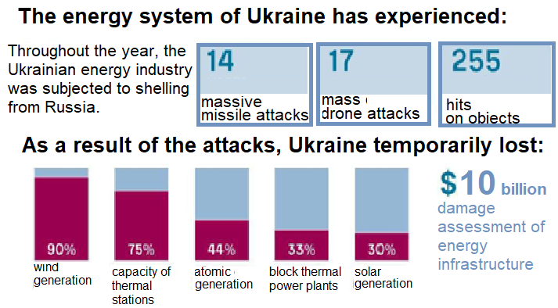
Figure 1 - The state of Ukraine's energy industry in 2022 of the full-scale invasions of the Russian Federation.
Since the beginning of the war, more than 3/4 of wind energy capacities in Ukraine have been destroyed and stopped, or about 1,462 MW out of a total of 1,673 MW.
Ukraine needs global changes in the restoration of energy systems. The task of the state is to create the necessary conditions, market rules and incentives for private investment. Ukraine should speed up and simplify approval procedures for new energy projects as much as possible. But at the first stage, the basis should be donor funds within the framework of the Program of Support and Reconstruction of Ukraine.
In recent years, foreign countries and, first, European Union states have gained a lot of experience in the consistent implementation of measures and mechanisms to increase energy efficiency based on economic incentives.
There are many solutions available within each step and their appropriateness and applicability will vary according to the development type, nature, and scale.
The energy hierarchy is used to guide and prioritise the steps which should be taken to minimising energy use and reducing associated GHG emissions. These steps are sometimes shown as [3]:
BE LEAN – take step to reduce energy consumption through improved fabric efficiency and low energy use lighting.
BE CLEAN – Seek to maximise efficiency of delivery of space heating requirements, such as communal boilers or district heat networks.
BE GREEN – Generate heat and electrical energy on-site and renewably to further reduce the developments carbon impact.
Increasing the use of renewable energy is important for the Ukrainian government to achieve its national and international goals.
Various financial incentives need to be put in place to allow renewable and low-carbon solutions to compete on an economic basis with conventional fossil fuels.
According to the Energy Security Strategy, it is necessary to introduce technologies for the transition of Ukrainians from fossil fuels to renewable energy sources, as well as to reduce the need for heat due to better insulation of buildings.
Work in Ukraine's electric power industry should focus on solar photovoltaic energy, biomass conversion, landfill gas, gasification and pyrolysis, as well as energy storage.
ADVANTAGES | DISADVANTAGES
The use of renewable energy sources and the reduction of energy consumption will lead to:  - reduction of emissions into the atmosphere and as a result of the implementation of the Paris Agreement on climate change and the possibility of Ukraine joining the EU;  - preservation of natural resources (oil, gas, coal, etc.);  - the country's transition to a "green tariff", which will make it financially independent. | In order to obtain positive results for the development of the energy sector of Ukraine, problematic issues may arise, such as:  - loss of time and opportunities. Prolonging hostilities with Russian aggression can lead to greater destruction and the impossibility of rebuilding the infrastructure. When the preservation of human life comes first;  - political capacity. Supporting other countries in military matters and investing in the energy sector of Ukraine;  - corruption. Financial control is necessary. The country's government should work not to increase its own wealth, but to rebuild, for the benefit of the state and the people.  - self-limitation. To be responsible, to reduce the need for energy use and to use energy-saving technologies in everyday life and in production.

References
- Official website of the Ministry of Energy and Environmental Protection. URL: https://mepr.gov.ua/.
- National energy "Ukrenergo" company. Electricity production in Ukraine for 2021. "Ukrenergo". URL: https://ua.energy.
- Research on energy efficiency in buildings. Official website of the International Energy Agency. URL: https://www.iea.org/topics/buildings.

