Oleksii Tretiak, Doctor of Technical Science, Associate Professor,
National Aerospace University “Kharkiv Aviation Institute”, Kharkiv
ORCID: 0000-0002-7295-5784
STUDYING OF THE HOUSING PARTS OF TURBOGENERATORS DURING THE AGING OF MATERIALS
When calculating the housing parts of high-power Turbogenerators, the following factors shall be taken into account namely thermal loads, vibration loads, pressure of cooling hydrogen, forces caused by the own weight of structural elements. As a rule, for the structural elements of the housing, the mechanical properties correspond to St3, the Young's modulus is 2.1·10⁵ MPa; Poisson's ratio is 0.3; the yield strength limit is 220, the calculated integrity class is 0, which corresponds to an isotropic structure in the absence of internal defects in metal [1].
For Turbogenerator rated 500 MW the box rests on the foundation and is rigidly connected to the stator body. At the same time, the front wall of the box is reinforced with stiffening ribs which are parallel and perpendicular to its sides.
When calculating the main components, it is necessary to take into account that in a real generator, the internal excess pressure is unevenly distributed over the box, this is especially noticeable in the place where the compressor is installed.
In Fig. 1 presents the standard calculation Diagram of the Turbogenerator box of the attachment design, which is used in the simplified analytical calculation. It is assumed that the box is under uniform internal pressure, and there are no mass forces. Zones with different pressures are taken into account by introducing additional empirical assumptions. The front wall of the upper half of the box is considered as a plate that rests freely on the contour and is supported by cross ribs, the influence of which is taken into account simply by “smearing” their stiffness over the plate. The calculation diagram of the front wall of the box is presented in Fig. 2.
As the result, it is not possible to describe accurately the operation of the ribs and additional connections between the power elements of the structure.
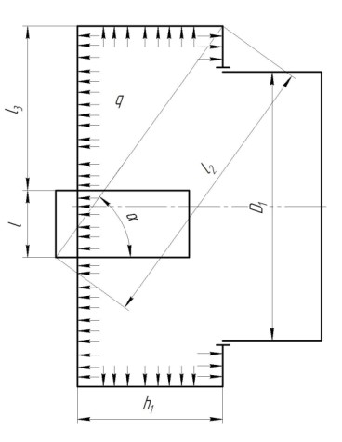
Fig. 1. Standard Calculation Diagram of the Box
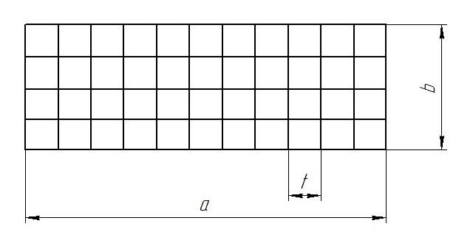
Fig. 2. Calculation Diagram of the Front Wall of the Box
Thus, the use of the analytical method for the box allows to determine only the average values of stresses and displacements. These results can be used at the stage of the sketch design of the structure, and during optimization and proofing, a calculation in a three-dimensional setting is required, which takes into account all the geometric features of the calculated elements and the nature of the application of loads. Among the significant shortcomings of the proposed methodology is the impossibility of calculating the actual condition of Turbogenerators that have been operating for many years.
The strength calculation consists of several stages [2]. At the first stage of the box strength study, a three-dimensional analysis of the operation of the generator ventilation system is carried out. As a result, the pressure and temperatures acting on the box are determined. Hydrogen cooling is used in these generators. At the next stage, based on the established values of excess pressure and temperatures, the stress-deformed state of the box is calculated.
In order to determine the pressures on the box walls, the hydrogen flow inside the box was calculated by the CFD method.
The following values were chosen as criteria for solution convergence: minimum, average, and maximum static pressure, average mass flow rate; on the surfaces of solid bodies the averaged heat flow was chosen. The calculation was performed iteratively until the convergence of the solution was achieved and at least three consecutive iterations were performed.
The pressure on the inner wall is 3 atm everywhere, except for the area where the compressor is located. In this zone, the pressure is determined by the compressor parameters.
Using the obtained grid, the study of the static strength of the box was carried out. In Fig. 3 shows the stress field on the inner surface of the box. Stresses are calculated according to Mises [3,4,5].
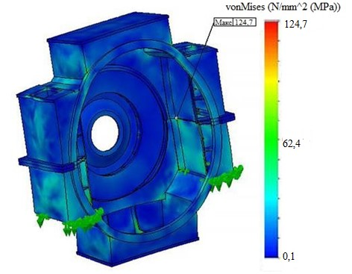
Fig.3 Stress Field on the Inner Surface of the Box
The maximum stresses in the box under a heavy excessive pressure of 5 atm was approximately 130 MPa. It is necessary to note that when using the classical analytical method, the maximum voltage in 1.5 times less, which is explained, first of all, in a simplified way, the expansion of the reinforced upper part of the box, if the infusion of the stiffening ribs is actually “smeared” along the surface of the plate, and also without balancing the temperature stress and the infusion of gravity. In the area of contact between the ribs and the plate, a stress concentration is observed that cannot be accounted for in an analytical manner [6].
One of the key problems is the lack of significant changes in the standard mechanical properties of pipe metal after long-term operation. Standard mechanical properties of metal practically do not differ from standard values, not only in the “old” products that are used for a long time. For used products, there is a problem of finding “standards for comparison”, due to the lack of “witness samples” and the “scatter” of the mechanical properties of existing samples of a certain year of manufacturing. The diagram of changes in the mechanical properties of the base metal is presented in Fig. 4.
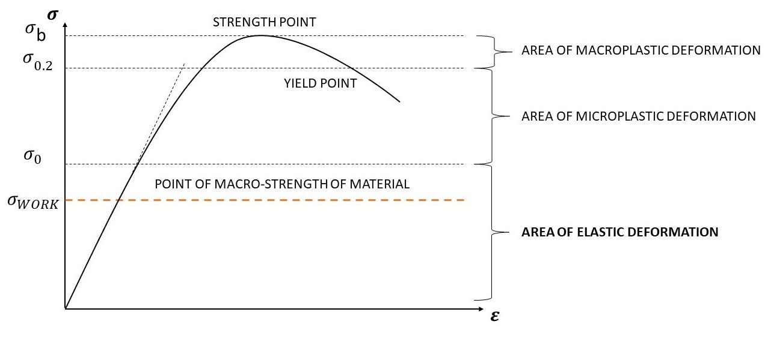
Fig.4 Diagram of Changes in the Mechanical Properties of the Base Metal
Nowadays, in order to determine the magnitude of the working mechanical stress, the practice has developed of using simplified methods based on standard mechanical tests. At the same time, for body parts, to eliminate the influence of the aging process, design stresses at the level of 130 MPa were previously used.
As shown by the results of studies using three-dimensional modeling methods [7], this value can be increased to 150 MPa. However, a necessary condition is the use of material with a continuity of at least 0. This is possible without additional control units.
Hydrogen is inside Turbogenerator. Since the mechanical properties of the surface layers of metals often differ from the internal ones: due to changes in structure and composition due to burning, decarburization, absorption of carbon, oxygen, hydrogen from the environment, the presence of internal stresses due to deformation during structural changes, due to differences in the thermal expansion of structural components e.t.c. These changes usually occur in thin layers, on the order of tenths of a millimeter. It is necessary to carry out a strict visual control of the structure.
The work “Analysis of the strength of high-power Turbogenerator assembly units to ensure their reliable operation under the influence of supercritical loads to ensure the energy security of Ukraine during martial law” registration number 224/0008 from 15 November 2023 completed within the project Cambridge – NRFU 2022. Individual research (developments) grants for researchers in Ukraine (supported by the University of Cambridge, UK).
References:
1. Tretiak, O., Serhienko, S., Zhukov, A., Gakal, P. et al., “Peculiarities of the Design of Housing Parts of Large Direct Current Machines”, SAE Int. J. Mater. Manf. 17(1):2024. ISSN: 1946-3979, e-ISSN: 1946-3987
https://doi.org/10.4271/05-17-01-0005
2. Mackerle J. Contact mechanics – Finite element and boundary element approaches. A bibliography (1995-1997). Finite Elements in Analysis and Design. 1998. Vol. 29, p. 275-285.
3. Letal J., Satmoko B., Manik N., Stone G. Stator End-Winding Vibration in Two-Pole Machines. IEEE Industry Application Magazine. November/December 2020, pp. 23. https://doi.org/10.1109/MIAS.2020.2982725
4. Yuling He. Electromagnetic Force and Mechanical Response of Turbo-Generator End Winding under Electro-mechanical Faults. Mathematical Problems in Engineering. December 2021. Vol 1. Pp. 1–19. https://doi.org/10.1155/2021/9064254
5. He Y., Gerada D., Ming X.X. Impact of stator inter-turn-short-circuit position on end winding vibration in synchronous generators. IEEE Transactions on Energy Conversion. 2020. Vol. 36. No. 2. Pp. 22–27.
https://doi.org/10.1109/TEC.2020.3021901
6. Meng Q., He Y. Mechanical response before and after rotor inter-turn short-circuit fault on stator windings in synchronous generator. Proc. of the 2018 IEEE Student Conference on Electric Machines and Systems. Hu Zhou, China, December 2018, pp. 1–7. https://doi.org/10.1109/SCEMS.2018.8624696.61.031
7. Tretiak, O.; Kritskiy, D.; Kobzar, I.; Sokolova, V.; Arefieva, M.; Tretiak, I.; Denys, H.; Nazarenko, V. Modeling of the Stress–Strain of the Suspensions of the Stators of High-Power Turbogenerators. Computation 2022, 10, 191. https://doi.org/10.3390/computation10110191

