Andriy Topolskiy., PhD student, Vinnytsia
National Technical University, Vinnytsia
ORCID: 0009-0007-7631-0872
Yevhen Palamarchuk, Cand. Sc. (Technology),
Associate Professor, Vinnytsia National
Technical University, Vinnytsia
ORCID: 0000-0002-7443-099X
METHODS OF STUDENT INTERACTION WITH THE AUTOMATED ATTENDANCE SYSTEM IN HIGHER EDUCATION INSTITUTIONS
The tasks of an automated attendance system in higher education institutions are to collect the necessary data about students, send it to the server, process it, and draw a conclusion about the student's presence in class. The main criteria for such a system are its degree of automation (level of students’ or teachers’ involvement in the process) and the precision of students’ position calculation.
To ensure minimal user involvement in the system it should be based on wireless technologies so that a person does not have to manually use the system, for example, by bringing a tag next to a scanner. The components of such a system are sensors, sink nodes and a server. A sink node is needed to form raw data from sensors into data packets. In addition, the sink node acts as an interface between the sensor system and the external network [1].
The process of the automated student identification system involves the following steps:
1. Student identification (interaction with sensors);
2. Transferring data from the scanner to the sink node;
3. Transferring data from the sink node to the server;
4. Data processing.
The task of student identification is to read certain unique information about the student, such as a unique ID, smartphone Mac address, student's face or student's fingerprint [2].
Depending on the system's algorithms, there are two methods of user interaction with the system: active student and passive student. The system with an active student involves the initialization of the algorithm by the student. For example, scanning a QR code, authorization in a smartphone application, and pressing a button on the device. One example of such a system is the usage of Bluetooth based on iBeacon technology [3]. iBeacons store data about the room where they are installed. Students use their smartphones to scan their surroundings and connect to the beacon in the current room. In response, the beacon provides its data to the smartphone, then the application sends this data to the server via the Internet. A diagram of such a system is shown in Fig. 1:
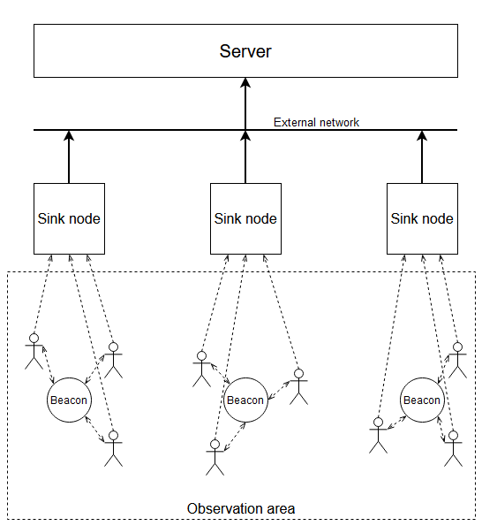
Figure 1 - automated identification system with an active student
A system with a passive student involves the initialization of the algorithm by sensors. In this case, students can be considered only as an observed phenomenon, not as a user of the system. Examples of such systems include the use of RFID technologies [4]. Each student carries a passive RFID tag with the student's ID. RFID readers scan their surroundings, read data from RFID tags, and then send this data to the sink nodes. A schematic of such a system is shown in Fig. 2:
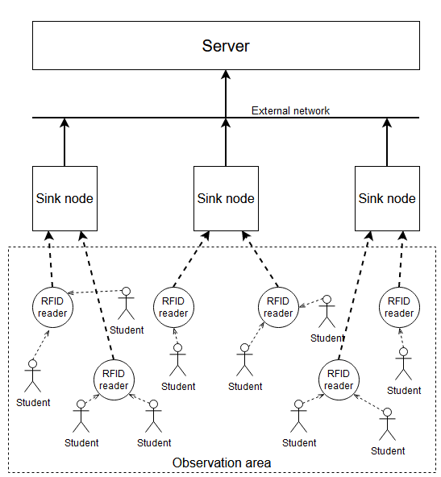
Figure 2 - automated identification system with a passive student
The advantage of a system with an active user is that with this algorithm the precision of the student's position calculation is high because the student connects to the system independently, indicating where and when he or she is. The disadvantage of such a system is that the student is actively involved in the system's algorithm, i.e. it is not fully automated.
In the case of a system with a passive user, the task of identifying a student is performed solely by devices, which is why there is a possibility of error in calculating his or her location. This increases the complexity of the hardware and software components of the system compared to a system with an active user but allows for full automation of the process and eliminates the need for students or teachers to be involved in the process.
Conclusions. The methods of interaction between students and the automated attendance system in higher education institutions were examined. The diagrams for each system were created for their comparison. Thus, the methods of automated identification systems with passive and active students were analyzed. It is shown that in terms of complexity and cost of the system, the method with an active student is more suitable, and for the full automation of the system the method with a passive student is more suitable.

References:
- H. Karl and A. Willig, “Protocols and Architectures for Wireless Sensor Networks,” John Wiley & Sons, Hobo-ken, 2005.
- A. Topolskiy, Y. Palamarchuk, “Automated attendance systems for higher education institutions”, Інформ. сусп-во: технол., екон. та техн. аспекти становлення (вип. 81), м. Тернопіль, м. Ополе, Україна, Польща, 11–12 жовт. 2023. Тернопіль: ГО “Наук. спільнота”, 2023, с. 3–5.
- C, Shalini K. “Digital Attendance System Using IBeacon along with Indoor Navigation.” International Journal for Research in Applied Science and Engineering Technology 8, no. 8 (2020): 245–47. DOI:10.22214/IJRASET.2020.30861
- Abdulsada Hayder, “Design and Implementation of Smart Attendance System Based On Raspberry pi“, JUBES, vol. 25, no. 5, pp. 1610-1618, 2017

