Anatoliy Demchyshyn, PhD, associate professor,
Ganna Smakovska, postgraduate student
National Technical University of Ukraine
"Ihor Sikorskyi Kyiv Polytechnic Institute"

INFORMATION TECHNOLOGIES IN THE CONSTRUCTION OF
AWNING STRUCTURES

Today, there are many different methods of computer modeling, depending on the scope, purpose of the study and the composition of the models used. All of them are powerful analytical tools that have absorbed the entire arsenal of the latest information technologies, including graphical shells for modeling and interpretation of initial simulation results, object-oriented programming, Internet solutions, etc. [1].
Analysis of the latest research and publications by domestic and foreign scientists showed that technical means are becoming more complicated, and construction materials remain standard. This leads to new requirements for design tools, which must solve the task of finding the optimal cutting of structural materials for the production of technical objects.
Since awning structures in modern socio-economic conditions are gaining more and more popularity today due to their wide properties, there is a need for the rapid construction of low-cost buildings to overcome the shortage of mobile housing and other purpose buildings. There is a need to use special methods that are based on the use of the equilibrium state of membranes used in construction.
For non-expandable surfaces, the requirement "to preserve a certain geometric property as accurately as possible" is realized in the form of minimizing distortions. However, despite the presence of a large number of scientific works on this problem, this category is not sufficiently studied.
Recently, light, cost-effective awning structures have become more and more popular (Fig.1). They belong to the class of soft shells. Such constructive systems are spatial membranes with zero bending stiffness, which consist of complex surfaces of double curvature [2]. These coatings can resist only in tension.
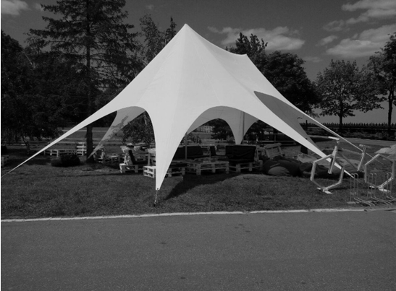
Fig.1 The awning structure of the summer cafe for various events

Therefore, their perspective is obvious due to the presence of a whole set of positive properties in them, which favorably distinguishes awning structures from traditional ones, such as metal, reinforced concrete, etc.[3]. Such properties include: mobility, multi-functionality, lightness, a short period of construction and dismantling, as well as an expressive, attractive and modern appearance.
For choosing design solutions, an important factor is the service life of awning structures, as well as their cost. The term of use depends on the choice of fabric for the shell. The fabric itself has different strength and elasticity in all directions of load application. Therefore, for stressed structures, materials with low creep will be better, because the previous stress can be lost if the fabric is stretched or deformed.

References
- Raikovska G. Geometrychne modeliuvannia – osnova konstruktorskotekhnolohichnykh zdibnostei / G. Raikovska, V. Golovnia // Nova ped. dumka: naukovo-metodychnyi zhurnal - 2013. - № 1 Ch. 2. – S. 68-70.
- Calegari, D. Notes on minimal surfaces. University of Chicago 38, 2014.
- Antonenko I.V. Osoblyvosti formuvannia vnutrishnoho prostoru budivel i sporud za dopomohoiu tentovykh konstruktsii. Materialy XI Vseukrainskoi praktychno-piznavalnoi konferentsii «Naukova dumka suchasnosti i maibutnoho», 2017.

