Pylypenko Artem Olegovich.

National Technical University of Ukraine "Ihor Sikorsky Kyiv Polytechnic Institute", Kyiv

Department of information and measurement technologies, master's student

Markina Olga Mykolayivna

National Technical University of Ukraine "Ihor Sikorsky Kyiv Polytechnic Institute", Kyiv

Department of information and measurement technologies, associate professor

Maksym Oleksandrovych Markin

National Technical University of Ukraine "Ihor Sikorsky Kyiv Polytechnic Institute", Kyiv

Department of information and measurement technologies, associate professor

DIGITAL MICROSCOPE

The main elements of a digital microscope are an optical microscope, a CCD camera and a personal computer with appropriate software for capturing and processing video images. When conducting experimental research, an optical microscope is a key part of measuring systems. The high operational characteristics of the optical microscope, such as ease of use, reliability, minimal impact on the measurement object, speed of obtaining results, and relatively low cost, often make it a choice in favor of other measurement methods, such as scanning electron or atomic force microscopy. The development of optical microscopes has turned them into highly automated measuring instruments - digital microscopes, where the image profile of the controlled element is recorded and processed using a computer. This allows you to avoid subjective errors and achieve high reproducibility of measurements of linear dimensions in thousandths of a micrometer. Among the disadvantages of the optical microscope, it is worth noting the problem with the light source. But this will not be the subject of our research. Among the advantages of the optical microscope should be noted its low cost, ease of use, as well as wide use in scientific and educational institutions, which makes them accessible to many users.

In the work, a digital microscope consisting of several main components was chosen, which allows for measurement and observation of objects on a microscopic scale. The basis of its work is a combination of optical and electronic components that provide magnification and display of the image of objects.An optical microscope is part of a digital microscope and is used to magnify objects. Standard optical components such as lenses and glasses are used to form the magnified image. LEDs or other light sources are built into the microscope to illuminate the object being examined. It can be an LED or other light source that allows you to get clear and detailed images. The main elements include the camera, which converts the image obtained by an optical microscope into an electronic signal. This signal is sent for further processing and display on the screen. The received electronic signal is processed by an electronic system to improve contrast, adjust colors and other parameters. And the already processed image is displayed on the screen for the user to view. The ability to observe the image on the screen allows you to output data for analysis or storage. A digital microscope also has software for image processing and storage. The software allows the user to process the received image, use various functions, and save the received data for further use or analysis.We will describe the operation of a digital microscope. The light reflected from the object passes through the optical path of the microscope, is magnified and forms an image on the illuminated field. At this time, LEDs or other light sources are positioned to illuminate the object and help obtain a clear image. The television camera of the digital microscope converts the optical image into an electronic signal. The received signal is sent for processing and display. In turn, the received object image is processed, including signal amplification, contrast support, color settings, and other parameters. And the received image is displayed on the screen and the user can observe and analyze the image on the monitor. The image can be saved and processed with software. The software allows the user to save the acquired data for further use or analysis.

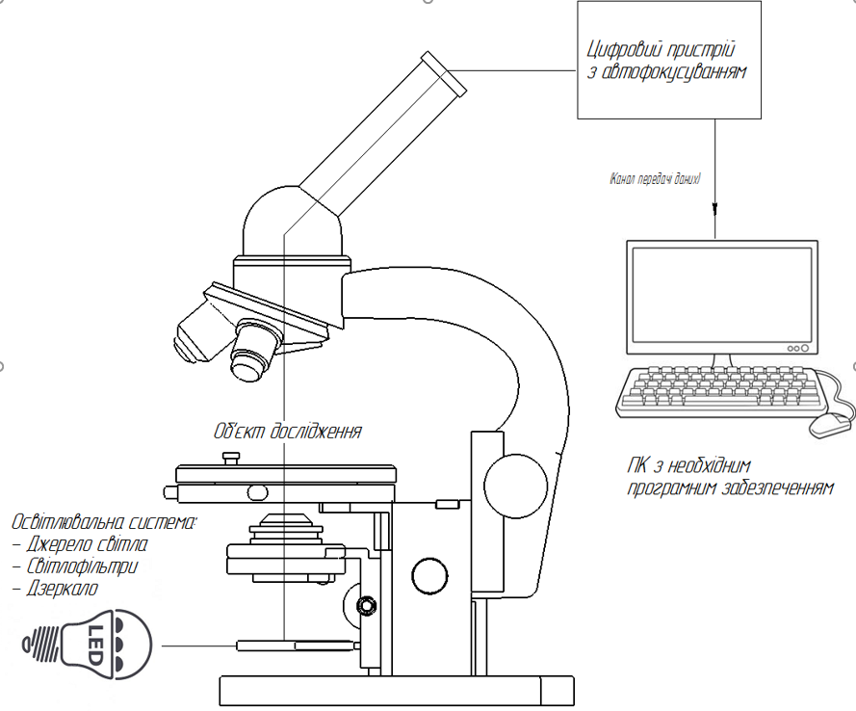

Figure 1 – Digital microscope [1, 2]

Digital microscopes provide convenience and applicability in fields such as science, medicine, education, and industry through the harmonious interaction of optical and electronic technologies [1-3].

References:

1. Markina O.M. Dissertation for obtaining the scientific degree of Candidate of Technical Sciences on the topic of Improvement of the television measurement system for determining the geometric dimensions of topological elements such as scales and grids, 2015, 132 pages.
2. Olga M. Markina, Maksym O. Markin, Maryna V. Filippova, Damian Harasim, Kanat Mussabekov, Azamat Annabayev, "The peculiarity of the construction of an optical-electronic system for measurement of geometrical parameters of objects in the micrometer range" , Proc. SPIE 10445, Photonics Applications in Astronomy, Communications, Industry, and High Energy Physics Experiments 2017, 104456B (7 August 2017); doi: 10.1117/12.2280987; <http://dx.doi.org/10.1117/12.2280987>.
3. Markina O.M. Research of illuminating parameters halogen-filled and LED lamp for optoelectronic measuring system / O. M. Markina, M. O. Tykhan // Archives of Materials Science and Engineering. – 2018. Vol. 94, Is. 1. – PP. 18-26. (https://archivesmse.org/resources/html/article/details?id=183221).