Pinkas Mariia Vasylivna, student, National Technical University of Ukraine

“Igor Sikorsky Kyiv Polytechnic Institute”, Kyiv, Ukraine;

Cheropkina Romaniia Ivanivna, Candidate of Technical Sciences, Associate Professor of the Department of Ecology and Technology of Plant Polymer Science,National Technical University of Ukraine “Igor Sikorsky Kyiv Polytechnic Institute”, Kyiv, Ukraine

**TENDENCIES OF MANUFACTURE OF PACKING MATERIALS FROM CARDBOARD**

Huge loads on pollution of the environment createthe production of plastic, as these materials are not laid out, but only accumulated. Therefore, every day in the world today begins with the search for alternative materials to replace existing synthetic plastics, especially in the packaging industry [1].

Different types of cardboard are used for packaging products, which are positively distinguished by biodegradability*,*easily*,* high strength, universal application, effective protection, and availability.

Taking into account the work of pulp and paper industry in 2022 the main kinds of paper and cardboard, which were produced were containerboard, market pulp, cartonboard, printing and writing, and tissue and towel, fig 1. [2].

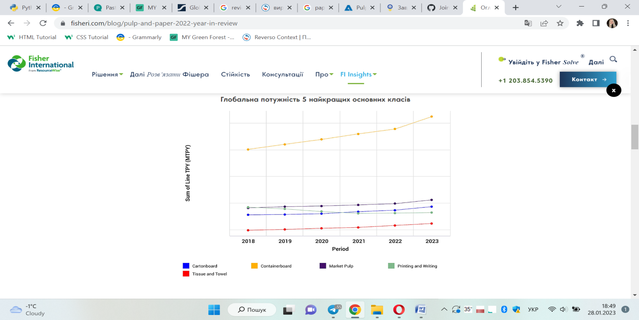

Figure 1. General trends in the production of popular types of cardboard and paper products

From the data of Fig. 1 one can conclude that the production of containerboard significantly exceeded in recent years and is also expected to increase its production. Among other types, there is a tendency to increase the production of containerboard and tissue and towel. On the contrary, the production of paper for printing since 2019 has gradually decreased and, according to forecasts, such regularity will be preserved in the future. Figure 2 shows changes in paper and cardboard production worldwide from 2010 to 2021 by type [3].

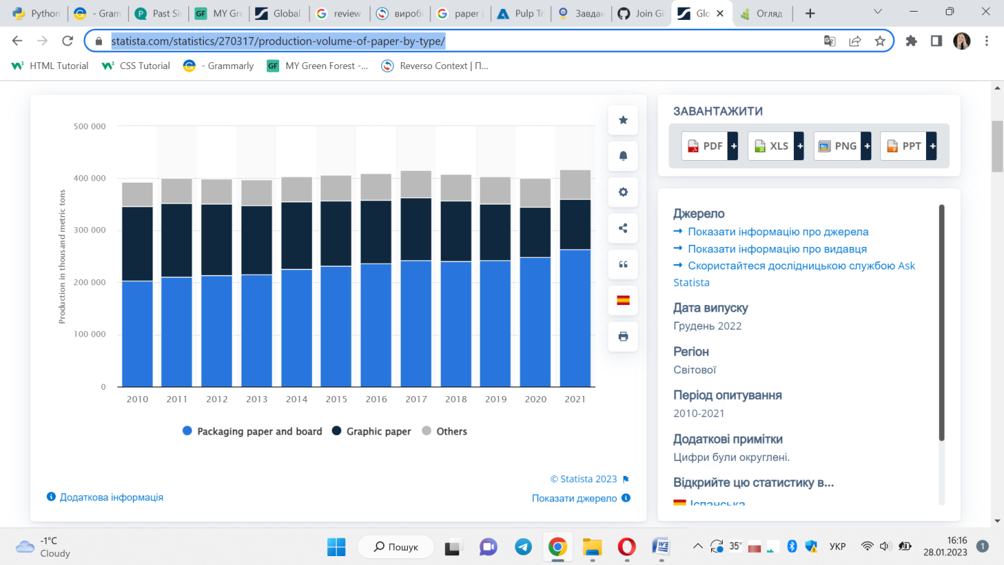

Figure 2.Production volume of paper and paperboard worldwide from 2010 to 2021, by type

As can be seen from the data of Fig. 2 in the period from 2010 to 2021, the volume of production of packing paper and cardboard increased by 33 %. It should be noted that in the period from 2020 to 2021 production growth reaches 6 %. This is easily explained by the large demand for packaging due to increased commercial sales in food and other sectors.

According to the latest data in 2021, the largest, 178 million tons, was produced of containerboard. The world [demand](https://www.statista.com/statistics/1090439/global-containerboard-demand/" \t "_blank) for this kind of cardboard is expected to grow to more than 220 million tons by 2031. Cardboard packaging is an important type of cardboard used in the production of corrugated cardboard [3,7].

Analysts note that it was corrugated cardboard in the world in 2021 was the most produced and its share made 44 % from all kinds of packing cardboard [3].

According to the volumes of production of graphic papers, which include paper for printing and for writing, drawing in the period from 2010 to 2021, there was a decrease of 49 %, and only 0,6 % increased in the period from 2020 to 2021. This regularity is explained by the increase of the role of online work in the predominant majority of spheres of life of people and therefore the need to use paper falls.

Production of all other types of paper, depending on the purpose, namely decorative, electrical, wrap, light sensitive, for the production of cigarettes and cigarettes, the chemical, industrial-technical from 2010 to 2021 increased to 21 %. In one year, from 2020 to 2021, the increase was about 2 % and, mainly, by the definition of analysts at the expense of sanitary-hygienic types of paper.

The dynamic of progressive demand for cardboard products is dictated by a number of directives adopted in recent years in the European Union countries which restrict the use of plastic [4].

It is common to note that one of the important factors for the growth of human well-being is the consumption of paper per capita. Countries such as Luxembourg, Germany, Austria, USA, Japan, Finland is positioned as the world's largest per capita paper consumer, with approximately 200 to 277 kg of paper per person per year [5].

The statistics confirm that in 2021 the world consumption of paper and cardboard amounted to 408 million tons. Consumption is expected to continue to grow over the next decade and may reach 476 million tons by 2032. The largest share [of world trade paper and cardboard](https://www.statista.com/statistics/270317/production-volume-of-paper-by-type/) is on packing (fig.3) [6].

The cards made of secondary raw materials (liner test) proved to be competitive among all materials used for packaging. Since the opening of recycled paper as a fibrous semi-finished product in cardboard and paper production, it is the main source of raw materials supply to enterprises. However, in order to meet growing demand in tarpaulins, it is necessary to constantly find additional sources of raw materials in the form of recycled paper.

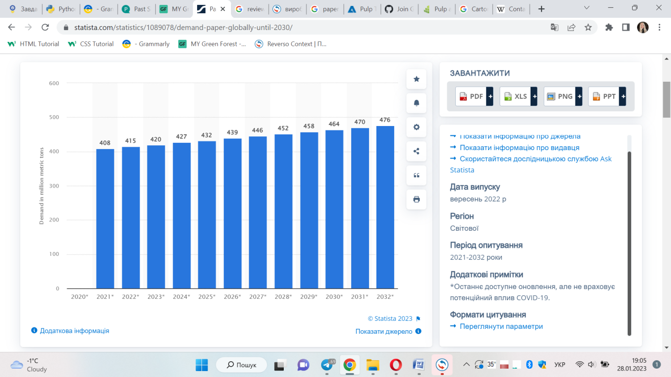

Figure 3. Paper consumption worldwide from 2021 to 2032

Analysis of the latest world statistics on the number of solid household waste generated in the year is 2,01 billion tons. It is noted that about 20 % of the total amount of solid household waste is paper and cardboard, which can be successfully sorted and used as secondary fiber [7].

In general, the collection and processing of paper and cardboard as secondary raw materials is ecological, social and economic, regardless of the country.

Scientists show that about 35 % of wood viruses are spent on paper production, which is 1,2% of the total commercial production of the Earth. It is proved that the processing of one ton of paper printing, offset will save more than 2 tons of wood. In addition, paper from the primary fiber can be processed from 5 to 7 times, and in some cases more. According to statistics in 2017, the level of paper and cardboard recycling in Austria reached 83,5 %, Belgium 92,9 %, Germany 87,1 %, and Finland 100 % [8].

An important advantage of the reuse of secondary raw materials, according to the Environmental Protection Agency, is that the production of recycled paper requires 50 % less water and reduces air pollution by 74 % compared to the production of primary fiber paper[9].

Thus, it is possible to draw conclusions on the preservation of the tendency of demand for packing of cardboard, which is characterized by ecological and renewal. In this context, the role of recycled paper amounts to reducing the environmental burden, as well as its use as a full-fledged raw material for the production of different types of paper and cardboard.

**List of references**

1. Trends and challenges in the development of bio-based barrier coating materials for paper/cardboardfood packaging; a review. Access mode: <https://www.sciencedirect.com/science/article/pii/S0048969722054274>

2.Pulp and Paper Industry 2022 Year in Review. Access mode: https://www.fisheri.com/blog/pulp-and-paper-2022-year-in-review

3. Production volume of paper and paperboard worldwide from 2010 to 2021, by type. Access mode:<https://www.statista.com/statistics/270317/production-volume-of-paper-by-type/>

4.Рlastics and packaging laws in the european union. Access mode: <https://cms.law/en/int/expert-guides/plastics-and-packaging-laws/european-union>

5. Largest per capita paper consuming countries worldwide in 2015. Access mode: <https://www.statista.com/statistics/962605/largest-per-capita-paper-consuming-countriesworldwide/>

6.Paper consumption worldwide from 2021 to 2032. Access mode: <https://www.statista.com/statistics/1089078/demand-paper-globally-until-2030/>

7. Food packaging from recycled papers: chemical, physical, optical properties and heavy metal migration.Access mode: <https://www.sciencedirect.com/science/article/pii/S2405844022022472>

8. Recycling rate of paper and cardboard packaging waste in the European Union in 2020, by country. Access mode: <https://www.statista.com/statistics/1033512/recycling-rate-of-paper-and-cardboard-packaging-waste-in-the-eu-by-country/>

9. U.S. Environmental Protection Agency. Access mode: <https://www.epa.gov/>