Mazur Tetiana Mykhailivna, Ph.D., Associate Professor,

Ivano-Frankivsk National Technical University of Oil and Gas, Ivano-Frankivsk

ORCID: 0000-0002-4047-832X

Mazur Myroslav Pavlovych, PhD, Associate Professor,

Ivano-Frankivsk National Technical University of Oil and Gas, Ivano-Frankivsk

ORCID: 0000-0002-5746-9876

**THIN FILMS OF PвTе AND CdTe: TRANSPORT PROPERTIES AND POTENTIAL APPLICATIONS**

Thin films of cadmium telluride (CdTe) and lead telluride (PbTe) are promising materials for microelectronics and optoelectronics, particularly in infrared radiation sources, X-ray and gamma radiation detectors, and thermoelectric energy converters. This study investigates the transport phenomena in these polycrystalline films, focusing on charge carrier mobility, scattering mechanisms, and activation energies. The results reveal that grain boundary scattering and surface effects significantly impact electrical properties, influencing film performance in various applications.

Cadmium and lead telluride films exhibit unique electronic and transport properties, making them highly valuable for advanced device applications. CdTe is particularly suitable for photovoltaic converters, with a theoretical efficiency of 29%, though practical values remain at 12% due to transport property limitations. In contrast, PbTe films show potential for thermoelectric and infrared applications. Understanding the influence of film thickness and microstructure on charge transport is critical for optimizing these materials.

The films were obtained using the hot wall method, with deposition on glass substrates. The thickness was controlled by deposition time. Structural studies were conducted via X-ray diffraction, electron microscopy, and optical metallography. Electrical conductivity was measured in the temperature range of 77–300 K using the compensation method in constant electric and magnetic fields. The experimental setup included four Hall and two current contacts, with measurements performed under a magnetic field of 0.8 T. The measured sample had four Hall and two current contacts.

The Hall mobility of PbTe films exhibits a sharp decrease as thickness is reduced below 0.1 μm. This reduction is attributed to enhanced scattering mechanisms at grain boundaries and film surfaces.

The temperature dependence of the Hall mobility follows the power law

μ = μ0Т-n(d),

where n(d) depends on film thickness and dominant scattering mechanisms.

Carrier scattering is primarily influenced by surface and grain boundary effects, leading to a resistivity dependence described by Matthiessen’s rule:

$$\frac{1}{μ}= \frac{1}{μ_{s}}+ \frac{1}{μ_{b}} ,$$

where μ is the total mobility, μs is the surface mobility, and μb is the grain boundary mobility. Surface mobility was estimated using:

)-1

where λ is the mean free path, and *μV* is the bulk mobility. The model shows good agreement with experimental data for films thinner than 0.1 μm.

The average crystallite size (D) in PbTe films increases with film thickness according to:

D = 3,8 10-5d1/3

Smaller crystallites result in an increased density of grain boundaries, which act as potential barriers for charge carriers. Activation energy calculations indicate barrier heights of 0.09 eV for CdTe films and 0.06–0.1 eV for PbTe films, increasing with decreasing crystallite size (Fig. 1).

The conductivity of PbTe and CdTe films decreases with decreasing temperature due to enhanced scattering at grain boundaries. The observed activation energies suggest that thermionic emission over grain boundary potential barriers dominates carrier transport. A decrease in crystallite size increases the barrier height, further reducing mobility. The temperature dependence of carrier concentration indicates that acceptor levels are fully ionized in the studied temperature range, ruling out their contribution to conductivity changes.

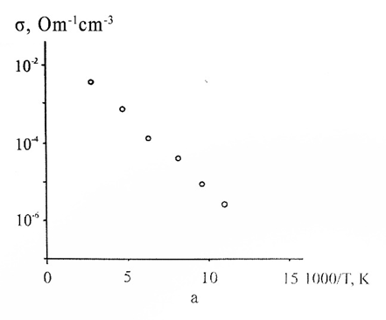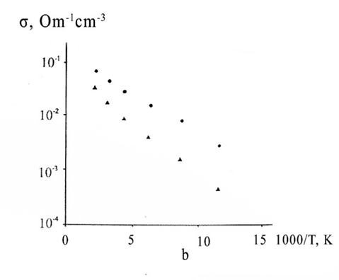

**Fig. 1.** Temperature dependence of electrical conductivity of p-CdTe (a) (L = 10-4 сm, Еb = 0.09 eV), p-PbTe films (b) (L, cm: ● – 1 10-6, ▲ – 2 10-7; Еb, eV: ● – 0.04, ▲ – 0.1) with different sizes of crystallites.

The temperature dependence of transport coefficients in p-CdTe and p-PbTe thin films was analyzed. The activation energies of intergrain potential barriers were determined to be 0.09 eV for p-CdTe films and 0.06–0.1 eV for p-PbTe films. It was demonstrated that the potential barrier model with traps, considering thermionic emission of charge carriers, effectively describes transport phenomena in these films. The results provide insight into optimizing polycrystalline thin films for improved electronic and thermoelectric performance, highlighting the role of microstructural control in enhancing material properties.

**References**

1. F.F. Sizov. Solid solutions of lead and tin chalcogenides and photodetectors based on them. *Foreign electronic equipment,* 24, 31-48, 1977.

2. T.M. Mazur, V.V. Prokopiv, M.P. Mazur, U.M. Pysklynets. Solar cells based on CdTe thin films. *Physics and chemistry of solid state,* 22(4), 817–827, 2021. <https://doi.org/10.15330/pcss.22.4.817-827>.

3. D.M. Freik, B. S. Dzundza, G. D. Mateik, Yu. V. Klanichka. Charge Carrier Transport in Low-disperse Cadmium and Lead Tellurides Films. *Physics and chemistry of solid state,* 7(2), 245-248, 2006.

4. O.A. Alexandrova, R.Ts. Bondokov, N.V. Saunin, Yu.M. Tairov. Mobility of charge carriers in two-layer structures PbTe/PbS. *Physics and technology of semiconductors,* 32(9), 1064–1068, 1998.