Magro Valeriy Ivanovich, PhD, associate professor,
Dnipro University of Technology, Dnipro, Ukraine
https://orcid.org/ 0000-0003-4238-6733
Morozov Valentin Mykhailovych, PhD, associate professor,
Oles Honchar Dnipro National University, Dnipro, Ukraine
https://orcid.org/ 0000-0001-6491-3499

STUDY OF THE INFLUENCE OF DIELECTRIC COATING ON THE RADIATION CHARACTERISTICS OF AN ANTENNA ARRAY

The development of production automation means has led to the replacement of human labor with automated mechanisms, including self-propelled machines. This technology is used in various industries, including industries with hazardous working conditions. However, in confined plant environments, it is not possible to use well-known moving object location technology such as GPS. Therefore, Real Time Location Systems (RTLS), also known as Real Time Tracking Systems, are used in confined indoor environments. Depending on the physical technology used, at least one and often some combination of location methods are used to determine location. One of the well-known methods is the angle of arrival (AoA) method, which requires the use of smart antennas [1-2] or phased antennas array.
The purpose of this study is to investigate the effect of the dielectric coating over a phased array antenna on the radiation characteristics of the array. In the case of using an antenna array of open ends of waveguides or a slot antenna array, it becomes necessary to use a dielectric coating in order to protect researchers from harmful influences, for example, from dust in a production room.
The work investigated the effect of a dielectric coating with different values of dielectric constant on the shape of the grating radiation pattern (Figure 1). The influence of the thickness of the dielectric coating on the radiation characteristics of the grating was also studied.
Conclusions: the use of a protective dielectric coating over the waveguide antenna array of the array radiation, while in each specific case, in order to improve these characteristics, it is necessary to perform additional optimization of the geometric dimensions of the array.

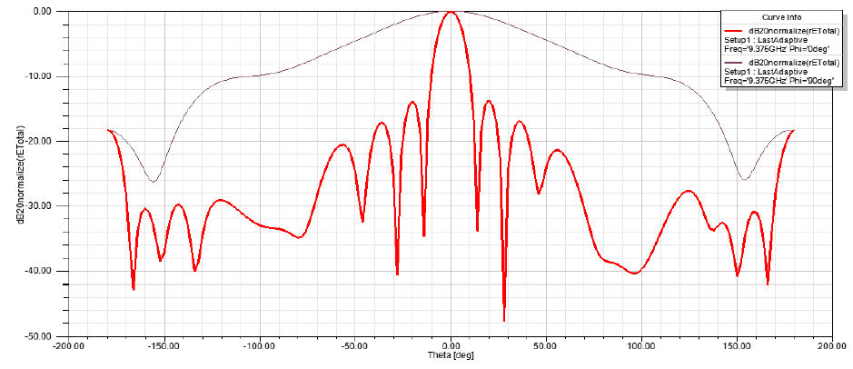
Figure 1. Effect of a 0.5 mm thick dielectric coating on the shape of the radiation pattern of a linear waveguide antenna array

Literature:
- Morozov V.M., Magro V.I. The feature of the use of the waveguide radiators in smart antenna systems // Journal of Physics and Electronics. 2018. Vol.26, No.1. P.89-92. https://doi.org/ 10.152421/331815
- Слюсар В. И. Развитие схемотехники ЦАР: некоторые итоги. Часть 2. // Первая миля. Last mile (Приложение к журналу «Электроника: наука, технология, бизнес»). 2018. № 2. C. 76-80. https://doi.org/ 10.22184/2070-8963.2018.71.2.76.80

