Levchenko Mykhailo, Master’s Degree Student
Stankevych Mariia, Assistant of the Department of Foreign Languages
National Aerospace University “Kharkiv Aviation Institute”
Kharkiv, Ukraine
0009-0000-1086-3588

DEVELOPMENT OF RECOMMENDATIONS FOR THE FURTHER USE OF LAND WITHIN THE ANTONINY AMALGAMATED TERRITORIAL COMMUNITY TO FACILITATE FURTHER ECONOMIC
GROWTH OF THE COMMUNITY

Efficient land use is a key factor for the economic growth of any community. Within the Antoniny amalgamated territorial community (ATC), a significant part of the land fund is used inefficiently or has the potential to be reoriented to more productive functions. The study conducted a spatial analysis of the existing land use structure, identified problem areas, reserve territories and promising areas for their functional use, taking into account current challenges and trends.
Currently, the official website of the community (Fig. 1) lacks geospatial information, which makes it difficult to make informed decisions for planning and investment [1].
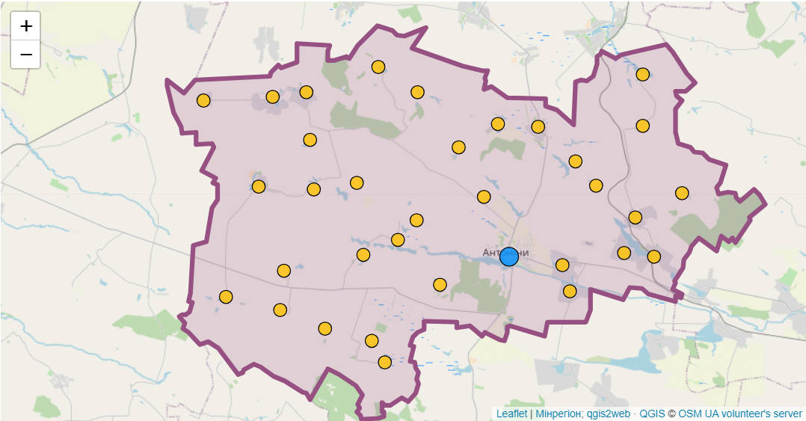
Figure 1. Map of the Antoniny ATC with the community boundaries and
main settlements
The analysis of the current state of land resources in Antoniny ATC showed a disproportion between the area of agricultural land, areas for construction, industrial zones and environmental protection sites. A significant part of the land is not used or is used for other purposes.
Since 1 January, 2025, a comprehensive spatial development plan has become a mandatory urban planning document for communities. Spatial planning will help not only to restore destroyed communities, but also to make communities resilient to future challenges, use resources efficiently and attract investment for the development of territories [2].
Adding new information about the state of land and its use to a community website will be an important tool for local residents, businesses, and potential investors.
Many thematic layers have been developed in ArcGIS (Fig. 2), which reflect various aspects of land use, such as boundaries, land of different forms of ownership, inventory objects, infrastructure facilities, etc.
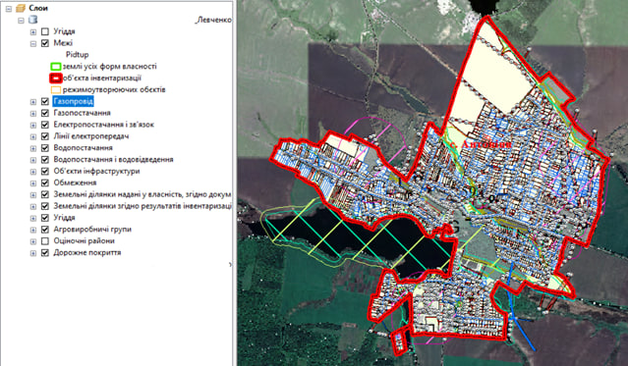
Figure 2. Thematic layers of land use and infrastructure developed in ArcGIS for spatial development planning of Antoniny settlement

The use of geographic information systems allowed for a multifactorial analysis of the territory, including an assessment of soil characteristics, transport accessibility, availability of engineering infrastructure and environmental constraints. The resulting layers will help to more accurately assess the current state of land use and find ways to improve it, especially in the context of updating assessment procedures. It is necessary to expand the available information about community land on the official website including assessment and planning materials. It is recommended to integrate information on land into online maps, which will make it easier for potential users to navigate and contribute to more effective decision-making for the development of the community’s economy [3].
GIS technologies should be more actively used for spatial analysis and assessment of land use efficiency.
Antoniny ATC has significant potential for further economic growth, provided that an integrated approach to land use is implemented. Based on the layers developed in ArcGIS, an in-depth analysis of land resources can be carried out and prospects for infrastructure and agricultural development can be identified.
It is important for the community to actively implement modern technologies in the management of territories, as well as to ensure transparency and accessibility of information on the state of the land. The introduction of comprehensive plans from January, 2025 will be an important step towards improving the efficiency of land use and creating conditions for sustainable community development.
References
1. Antonivs’ka selyshchna rada Khmel’nyts’koho raionu Khmel’nyts’koi oblasti hromada [Antoniny Settlement Council of Khmelnytskyi District, Khmelnytskyi Region community]. https://antoninska-gromada.gov.ua/ [in Ukrainian].
2. Detsentralizatsiia [Decentralization]. https://decentralization.ua/news/ [in Ukrainian].
3. Derzhavna sluzhba Ukrainy z pytan’ heodezii, kartohrafii ta kadastru. Metodychni rekomendatsii z provedennia normatyvnoi hroshovoi otsinky zemel’ sil’s’kohospodars’koho pryznachennia [State Service of Ukraine for Geodesy, Cartography and Cadastre. Methodological recommendations for conducting normative monetary valuation of agricultural land]. https://land.gov.ua [in Ukrainian].

