Kulikov O. A., graduate student

Ratushnyi O.V., candidate technical Sciences, senior teacher.

Department of Applied Hydroaeromechanics,

Sumy State University, Sumy, Ukraine

TRIMMING COUNTER-ROTOR STAGES AND THEIR CHARACTERISTICS

Trimming of the impeller is widely used in the finishing of centrifugal pumps, as well as to expand the area of their use. It is allowed to trim the impeller on the outer diameter by 10-15% to change parameters and sequential operation of two pumps. One of the most affordable ways is to trim the impeller along the outer diameter.

When using a contra rotating stage, the main pressure is created due to the negative swirl of the flow, which is created when the fluid leaves the impeller and enters the blade disc. In this case, the main characteristic is not the speed of the liquid flow, but the angle of its inflow to the entrance to the blade disc. When trimming the impeller, not only the overall dimensions of the wheel itself change, but also the angle of the fluid outlet.

How the contra rotating effect works. For ease of perception, the impeller and blade disc are dilivered to a distance «а» (fig.1). Velocity vectors and their components are given for the axisymmetric flow scheme and conditions 𝜔𝐼 = – 𝜔𝐼𝐼 (the gratings rotate in opposite directions with the same angular velocity). In addition, at the entrance to the first grid selected conditions without circulating leakage. The flow at the entrance to the second grid, is coming out of the first. It has a significant moment (twist), which is created by the first grid (𝜐𝑢2∙𝑟2). At the same time, its direction is opposite to the direction of rotation of the second grid.

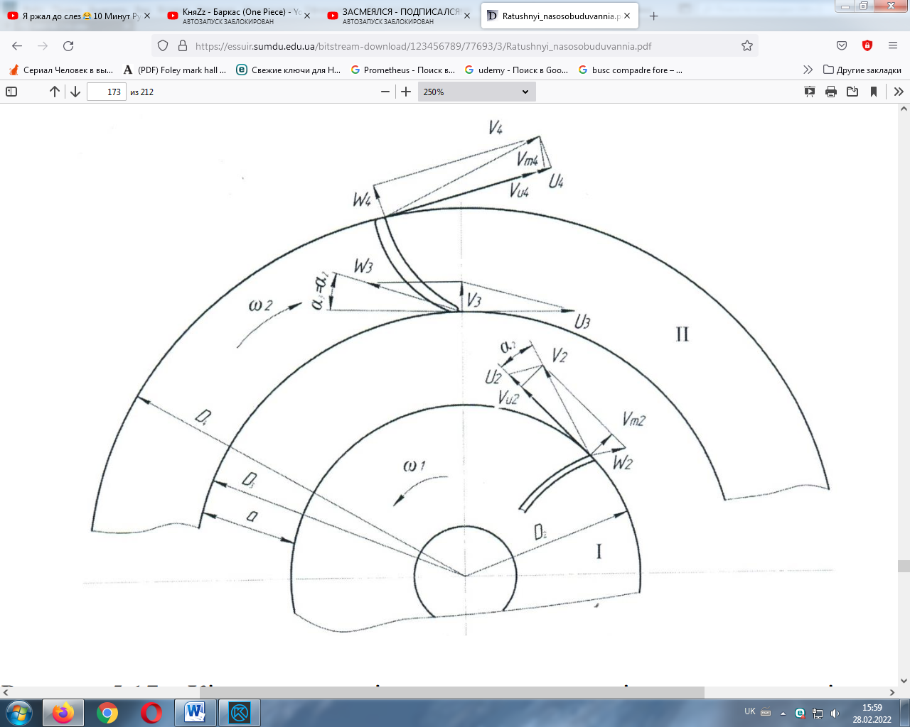

**Fig. 1**. Flow kinematics in contra rotating centrifugal systems.

It should be also noted that the blades of the second grid move towards the current coming from the first grid, changing its momentum in a very short time. And this, according to the moment theorem, causes a sharp increase in the force of interaction between the solid surface of the blade and the current that attacks it. This, obviously, leads to a significant increase in the intensity of the energy transfer process.

The object of the study is the contra rotating stage with the base impeller of the pump CNS 180-1900. In the first study is to so that the outer diameter of the impeller is constant D4=соnst. The second study is to so that the height of the blade disc is constant h=D4-D3=соnst.

All studies were carried out under the same conditions with a certain step of trimming of 5 mm. How can we see - the data received go with a certain step. Therefore, with the help of these values, we can obtain the energy and pressure characteristics of stages with any trimming. Based on the values obtained as a result of research, graphs of pressure, power and efficiency were constructed.

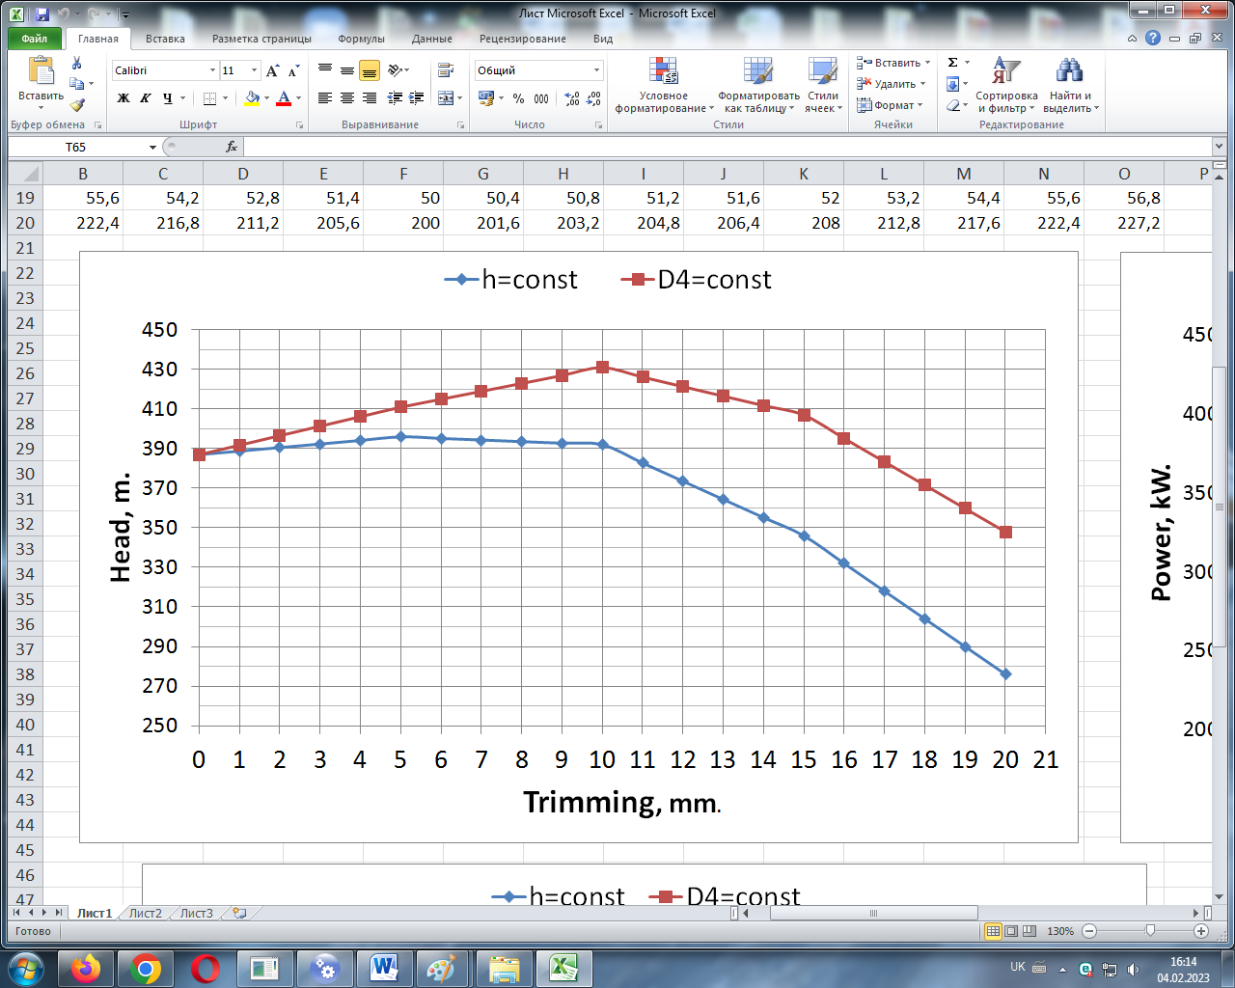 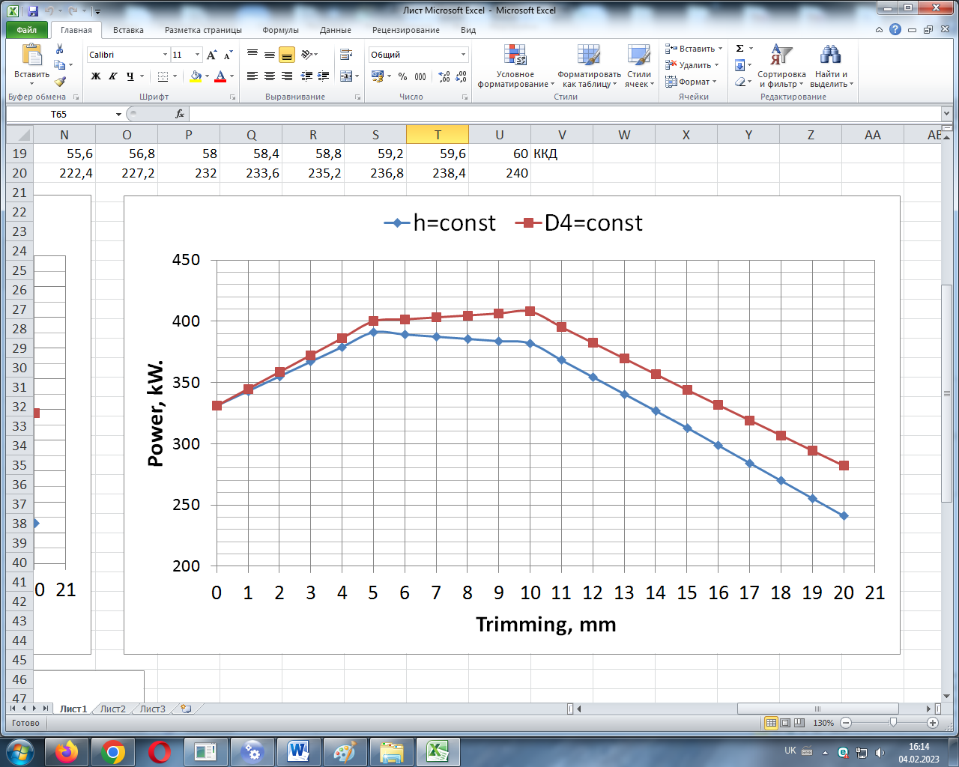

а b

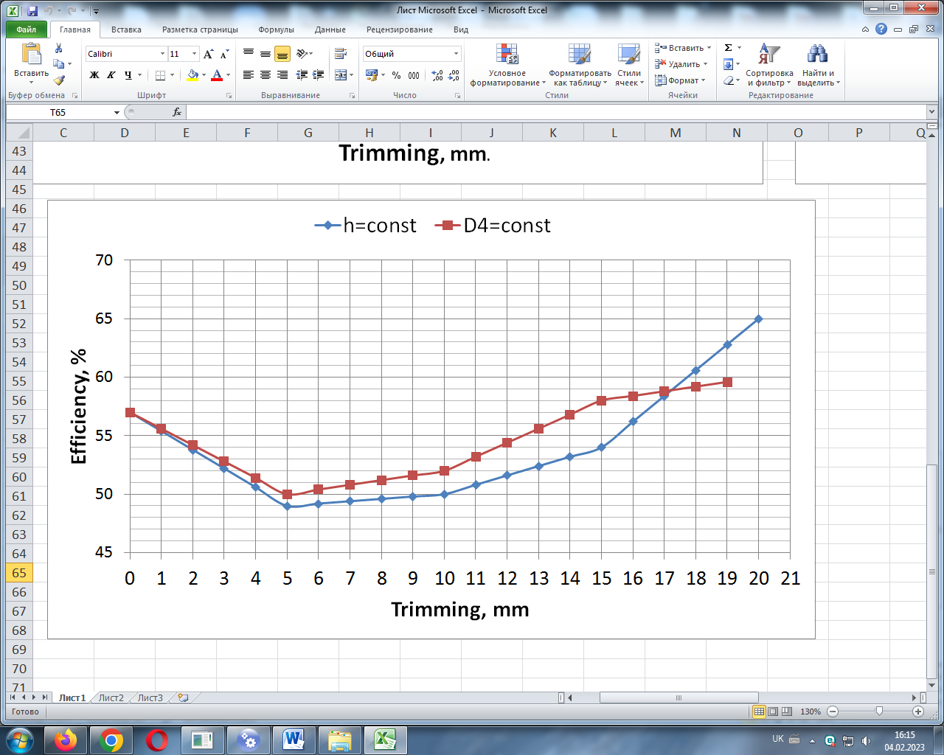

c

**Fig. 2.** Comparison: а – pressure characteristics, b - energy characteristics,

c - efficiency characteristics.

Having obtained the characteristics of contra rotating stages with different trimming, we can say that they have different pressure characteristics. Parameters can be both smaller and larger. When comparing two studies we will see the difference in characteristics. At first, pressure (fig. 2a) and power (fig. 2b) increase and reach their maximum at 10 mm of trimming. Then the characteristics begin to decline. Due to high power, the efficiency (fig. 2c) drops quickly, reaching its minimum of 5 mm and only then it begins to grow slowly.

As a conclusion, we can say that the pressure is affected not only by trimming, but also by the dimensions of the working part. Because with larger sizes, the liquid spends more time interacting with the blades of the impeller and blade disc. The time of interaction of the blade with the liquid has a corresponding effect on the pressure, since a larger amount of energy is transferred to the liquid for a longer amount of time. Based on these results, the impeller can be reduced by trimming it from 14 to 17 mm while maintaining good efficiency and pressure characteristics.