Mykola Korzachenko, PhD in Technical Sciences, Associate Professor
Chernihiv Polytechnic National University, Chernihiv
ORCID: 0000-0002-5674-8662
Iryna Prybytko, PhD in Technical Sciences, Associate Professor
Chernihiv Polytechnic National University, Chernihiv
ORCID: 0000-0002-8550-8318
Bohdan Korzan, Student
Chernihiv Polytechnic National University, Chernihiv
Tetiana Korobko, Student
Chernihiv Polytechnic National University, Chernihiv

Building Information Modeling in the Ukrainian Building Sector

BIM, or Building Information Modeling, is a digital technology that involves creating and managing a comprehensive digital representation of the physical and functional characteristics of a building or infrastructure. BIM technology goes beyond traditional 2D drawings and introduces a three-dimensional, object-oriented modeling approach.
Key aspects of BIM technology include:
1. 3D Modeling: BIM starts with the creation of a 3D digital model that represents the physical components of a building or infrastructure project.
2. Object-Based Modeling: Instead of representing elements as simple lines and shapes, BIM models use intelligent objects with defined parameters and relationships. These objects can be elements like walls, doors, windows, HVAC systems, etc.
3. Information Integration: BIM incorporates various types of information beyond geometric data. It includes data about materials, costs, schedules, performance characteristics, and more. This information is associated with the intelligent objects within the model.
4. Collaboration and Coordination: BIM facilitates collaboration among different stakeholders involved in a construction project, such as architects, engineers, contractors, and facility managers. It allows them to work on a shared digital platform, reducing errors and improving coordination.
5. Lifecycle Management: BIM covers the entire lifecycle of a building or infrastructure, from design and construction to operation and maintenance. It enables better decision-making at each phase and supports activities such as facility management and renovation.
6. Visualization and Simulation: BIM allows for realistic visualization of the project in 3D, aiding in better understanding and communication. It also supports simulations for various aspects, such as energy performance, structural analysis, and clash detection.
7. Data Analysis: BIM provides a rich source of data that can be analyzed for insights, efficiency improvements, and better decision-making. This can include energy analysis, cost estimation, and other performance metrics.
The use of BIM technology aims to improve efficiency, reduce errors, enhance collaboration, and streamline the overall construction and management processes. It has become a standard in the architecture, engineering, and construction (AEC) industry, offering a more holistic and data-driven approach to building design and management.
The Fields of Scientific Interests of Chernihiv Polytechnic National University:
1. The Additive Technologies of 3D-Printing and Scanning (Figure 1);
2. The Modelling of Buildings and Structures;
3. The Material Science;
4. Energy-saving Technologies in Welding;
5. Parametric design in construction, architecture and environmental design
6. Actual problems, concepts and principles of urban planning of smart cities.
One of iconic project of our team becomes the creation of the 3D model of 18th century fortification structure [1].

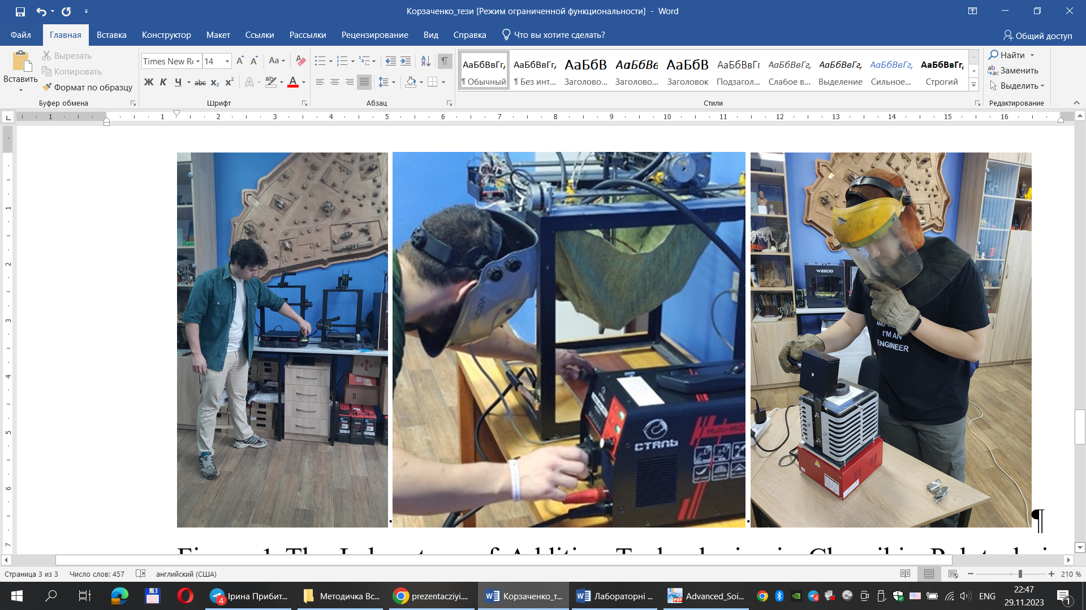
Figure 1 The Laboratory of Additive Technologies in Chernihiv Polytechnic National University

There are several Building Information Modeling (BIM) software programs used in the construction industry. The choice of BIM software often depends on factors such as project requirements, the preferences of the project team, and the specific features needed. Here are some popular BIM software programs:
1. Autodesk Revit: Revit is one of the most widely used BIM platforms. It is known for its comprehensive features that cover architectural design, structural engineering, and MEP (mechanical, electrical, and plumbing) systems [2].
2. AutoCAD Civil 3D: While AutoCAD itself is a widely used drafting software, AutoCAD Civil 3D is specifically designed for civil engineering and infrastructure projects. It includes BIM features for road design, land development, and other civil projects [3].
3. Graphisoft ArchiCAD: ArchiCAD is a BIM software solution for architects. It provides tools for creating and managing building designs, allowing architects to work in a 3D environment and generate detailed documentation [4].
5. Tekla Structures: Tekla is widely used in the construction industry for structural design and detailing. It is known for its advanced capabilities in modeling and detailing steel and concrete structures [5].
6. Trimble SketchUp: While traditionally known for its simplicity in 3D modeling, SketchUp has evolved to include more BIM-like features. It is often used for conceptual design and visualization [6].
It's important to note that the popularity and features of BIM software can change. Additionally, the choice of software can vary regionally and among different segments of the construction industry. Before selecting a BIM program, it's advisable to consider the specific needs of the project and the expertise of the project team.

References
1. Hanieiev Timur. Organizational and economic impact of implementation additive technologies in construction / Hanieiev Timur, Korzachenko Mykola, Bolotov Gennady, Yushchenko Svitlana // Academic journal. Series : Industrial Machine Building, Civil Engineering. – Issue 2 (55)`2020. – P. 115-120.
2. Autodesk Revit: BIM software to design and make anything. URL: https://www.autodesk.com/products/revit/overview?term=1-YEAR&tab=subscription&plc=RVT (date of application 29.11.2023).
3. Autodesk AutoCAD: Trusted by millions, built to accelerate your creativity. URL: https://www.autodesk.com/products/autocad/overview?term=1-YEAR&tab=subscription (date of application 29.11.2023).
4. ARCHICAD 24. URL: https://graphisoft.com.ua/uk/produkty/archicad-24/ (date of application 29.11.2023).
5. Tekla Structures - Structural BIM Software. URL: https://www.tekla.com/products/tekla-structures (date of application 30.11.2023).
6. SketchUp: 3D Design Software. URL: https://www.sketchup.com/ (date of application 30.11.2023).

