Kondus V., Ph.D. in hydraulic machines, Senior Lecturer1, 2

Ivchenko O., Ph.D. in hydraulic machines, Associate Professor2

Andrusiak V., Ph.D. student2

Petrenko S., Ph.D. student2

Polkovnychenko V., student2

Mushtai M., student2

1 Sumy Machine-Building Cluster of Energy Equipment, Sumy

2 Sumy State University, Sumy

**Designing An Updated Parametric Series Of Energy-Efficient Torque-Flow (TFP) Pumps For Transporting Municipal And Industrial Sewage**

One of the main tasks of ensuring the continuous development of mankind is the creation of prerequisites for technical progress, especially in the field of energy. From this point of view, an important guideline is the developed and implemented policy for achieving the so-called Sustainable Development Goals [1], in particular with regard to the necessary affordable and clean energy (goal #7), industrial development, innovation and infrastructure (goal #9).

As of today, industrial pumps and pumping equipment are one of the main consumers of electrical energy. According to existing estimates, the share of energy consumption by pumps and pumping equipment in the field of oil production and oil refining is 59% of the total level, water supply – 50%, chemical – 31%, pulp and paper industry – 26%, metallurgy – 15%, construction – 12%, etc.

In view of the above, an important task of reducing energy consumption by the world's population and industry is to reduce the electricity consumed by pumping equipment by increasing its energy efficiency [2].

It should be noted that currently torque-flow (TFP) pumps are widely used in industrial processes,because of their design, which provides for the possibility of pumping liquids with various types of inclusions (in particular, solid, fibrous, abrasive, etc.), liquids with high viscosity, high air or gas content, etc.

Due to their structural differences, they are used in the processes of transporting effluents of a wide range of physical and chemical characteristics in industrial and municipal systems, in the operating processes of various branches of the economy, in particular, the sugar and agriculture industry (pumping of molasses, juices, vegetable pomace, liquids with the inclusion of sugar beet pulp, bird trimmings with feathers, etc.), at enterprises in the field of critical infrastructure - thermal power plants (products with the inclusion of ash deposits, filtered mud, etc.), construction industry (water with impurities of sand, gravel, sludge, creosite mixtures, aerated concrete slurry, etc.), metallurgy and mining industry (coke, ash, carbon black, coal sludge, crushed slag), chemical industry (painting suspensions, catalysts, soda solutions, powders, etc.), petrochemical and pulp and paper industry (pulp, kaolin, decoctions, unenriched ores, water ethyl emulsions, benzenes, etc.).

However, the use of pumps of this type today is associated with very low energy efficiency indicators (Table 1) [3]. In turn, this is due to an inefficient choice of rotation frequency, which significantly reduces the pump specific speed ns (Fig. 1).

**Таблиця 1** – Показники енергоефективності насосів типу СВН

|  |  |  |  |  |  |  |  |
| --- | --- | --- | --- | --- | --- | --- | --- |
| **№** | **Pump Model** | **Flow rate, m3/h** | **Head, m** | **Electric Engine Power, kW** | **Rotational frequency, rpm** | **Specific speed, ns** | **efficiency, %** |
| 1 | SVN 20/10 | 20 | 10 | 2,2 | 1500 | 73 | 40 |
| 2 | SVN 25/20 | 25 | 20 | 4 | 1500 | 48 | 38 |
| 3 | SVN 25/20а | 20 | 18 | 4 | 1500 | 47 | 38 |
| 4 | SVN 25/20б | 16 | 16 | 3 | 1500 | 46 | 38 |
| 5 | SVN 25/32 | 25 | 32 | 11 | 1500 | 34 | 28 |
| 6 | SVN 25/32а | 20 | 28 | 7,5 | 1500 | 34 | 28 |
| 7 | SVN 25/32б | 16 | 25 | 5,5 | 1500 | 33 | 28 |
| 8 | SVN 40/40 | 40 | 40 | 15 | 3000 | 73 | 40 |

Thus, most small torque-flow pumps operate in the specific speed area ns = 30–50, for which the theoretically achievable maximum efficiency is 25–40%. Real efficiency of such pumps lies within 28–38%.

Increasing the shaft rotation frequency from 1500 rpm to 3000 rpm will allow increasing the specific speed ns up to 70–90, which are characterized by efficiency about 45–52%. In turn, this will allow to start updating the parametric series of torque-flow pumps by designing their new standard sizes [4].

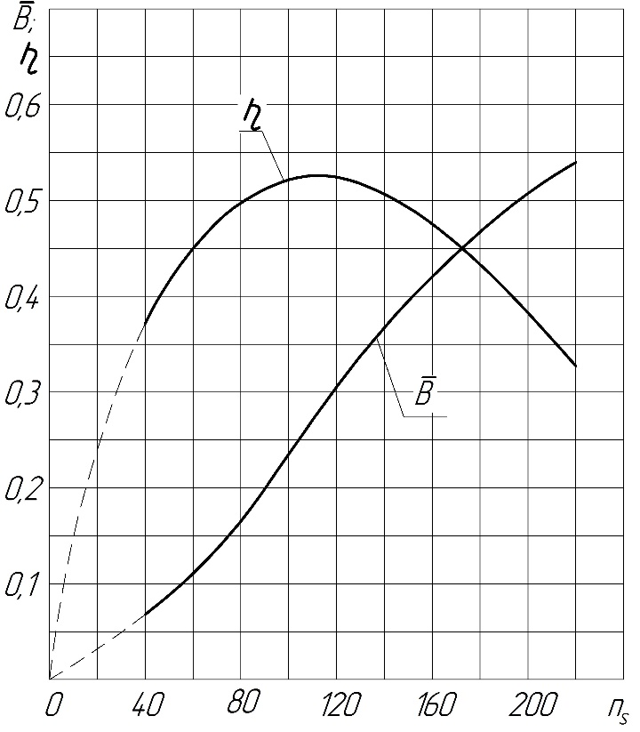

**Figure 1** – Dependence of torque-flow pumps efficiency of the specific speed ns

As a result, a significant increase in efficiency of torque-flow pumps (from 28% to 45%) is expected, which will reduce their electricity consumption by up to 60%.

In turn, increasing the rotation frequency of the pumps will allow to reduce the diameter of their impeller and, as a result, the overall dimensions of the pumps, which will allow to reduce their material capacity to 40–60% of existing analogues.

In order to achieve high energy efficiency and the general technical level of the updated parametric series, it is planned to use the analytical method of designing pumps, the method of numerical research of their flow parts and calculations for the strength of parts and assemblies, full-scale parametric tests using a special stand for parametric tests [5].

The development and design of updated energy-efficient pumps for industry meets the requirements of the "Strategy for economic recovery of the Sumy region until 2024", adopted and approved by the Sumy regional state administration [6]. In particular, under direction 2 "Industrial complex" it is planned to carry out a set of measures to create a competitive machine-building complex integrated into global production and capable of self-development. Currently, a powerful association of industrial potential in the field of development and implementation of energy equipment, "Sumy Machine-Building Cluster of Energy Equipment", has been created in the Sumy region. Works on the implementation of updated energy-efficient torque-flow pumps are planned to be carried out together with this association, which as a result will potentially allow to significantly improve the quality of products of Ukrainian machine-building enterprises.

**Literature**

1. THE 17 GOALS - Sustainable Development Goals [Electronic resource] – Access mode: <https://sdgs.un.org/goals>

2. Improving the efficiency of the operating process of high specific speed torque-flow pumps by upgrading the flowing part design / [V. Kondus, R. Puzik, V. German et al]. // J. Physics: Conference Series. – 2021. – №1741. – С. 012023. <https://doi.org/10.1088/1742-6596/1741/1/012023>

3. Kondus V.Y. A method of designing of torque-flow pump impeller with curvilinear blade profile / V.Y. Kondus, P.M. Kalinichenko, O.G. Gusak // Eastern-European Journal of Enterprise Technologies. – 2018. – № 3/8 (93). – P. 29–35. (Видання входить до наукометричної бази Scopus). <https://doi.org/10.15587/1729-4061.2018.131159>

4. Kondus V.Y. Improving the torque flow pumps product line / V.Y. Kondus, A.I. Kotenko, S.M. Yakhnenko // Nauka i Studia. – 2017. – № 11 (172). – P. 57–70.

5. Kondus V.Y. Investigation of the impact of the geometric dimensions of the impeller on the torque flow pump characteristics / V.Y. Kondus, A.I. Kotenko // Eastern-European Journal of Enterprise Technologies. – 2017. – № 1/4 (88). – P. 25–31. <https://doi.org/10.15587/1729-4061.2017.107112>

6. "Strategy for recovery and development of the economy of the Sumy region for 2022-2024" [Electronic resource] – Access mode: http://sm.gov.ua/images/docs/2022/strategia_2022-2024.pdf