Kelemesh Anton, master's degree in "Automobile transport"
Shevchenko Ihor, PhD of technical sciences, associate professor, head of the department of tractors and cars
State Biotechnological University (Kharkiv)
ORCID 0000-0001-9429-8570 Anton Kelemesh
ORCID 0000-0002-1280-5290 Ihor Shevchenko

ANALYSIS OF THE CHARACTER OF DEFORMATION OF BRONZE BUSHES DURING DIFFERENT TYPES OF PROCESSING

The technical condition of agricultural machinery is usually assessed by comparing the obtained actual parameter values with the specified technical conditions. The use of effective technological processes in the manufacture and restoration of parts contributes to increasing the resource of agricultural machines. Their insufficient reliability causes an increase in costs for restoration and operation [1].
One of the features of agricultural machines is the presence in their structures of a sufficiently large number of parts made of non-ferrous metals and alloys, which have high anti-friction properties and corrosion resistance. Most often, these are bronze sliding bearings of the "sleeve" type. For example, in the T-150 tractor, 36 bronze bushings are used, which are installed in various assembly units, such as: frame, transmission, engine, etc. In this regard, it is urgent to carry out research on the identification of the relationship between the technological parameters of processing during vibration deformation and the determination of the optimal values of the parameters of the technological process of the vibration processing of bronze bushings of agricultural machinery during their restoration, which ensure the necessary reliability and durability.
To study the nature of the deformation process of worn bronze bushings of camshafts, the samples were subjected to both normal and vibration loads. The nature of their deformation depends on the following main factors: the amplitude and frequency of oscillations of the machining tool, the size of its angle of inclination, the rate of deformation, the machining allowance, the material and size of the samples, the type of lubricant [2].
The investigated samples and processing punches are presented in fig. 1.
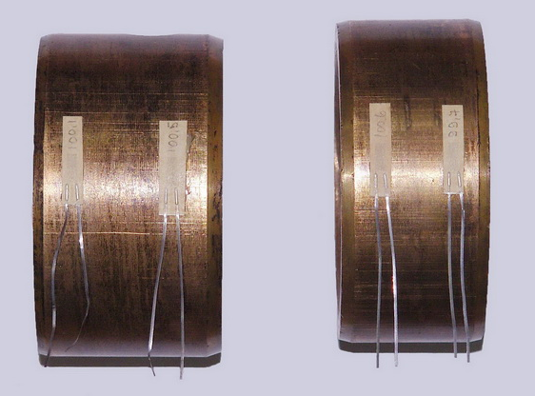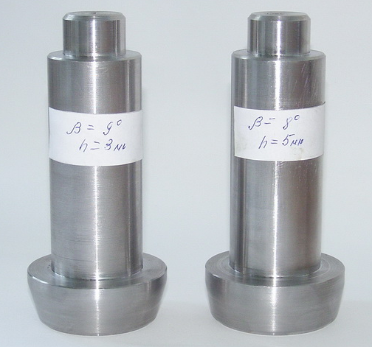
a b
Fig. 1. Applied samples and punches: a – samples; b – processing punches
The diagram of the contour of the deformed sample is shown in Fig. 2, where and is the value equal to the difference between the diameter of the calibrating belt of the punch and the inner diameter of the processed sleeve in the upper and lower parts, respectively.
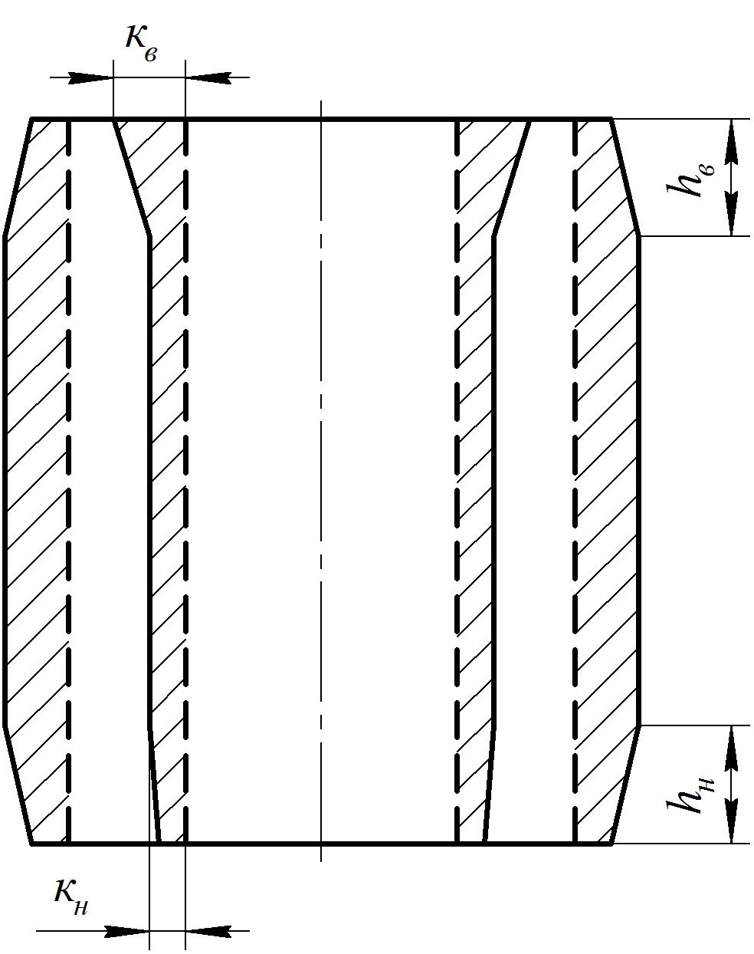
Fig. 2. Scheme of the contour of the sleeve deformation
These dimensions are deviated in the upper part by the length of mm during normal distribution and mm during vibration deformation, and in the lower part of the bushings, respectively, mm and mm. The values of and depend on the angle of inclination of the punch .
Research has established that the inner diameter of the samples in the upper belt after processing has a slightly larger size than the calibration part of the punch. This is explained by the fact that parts of the sample material move along the sliding lines from the working surface of the punch. In the lower part of the bushing, a family of sliding lines is directed parallel to the creation of the punch, which contributes to the reduction of the hole of the bushing after passing the punch.
On the basis of the obtained experimental data, graphical dependences of the change in the outer diameter of the bushings during normal and vibrational deformation were constructed (Figs. 3, 4).

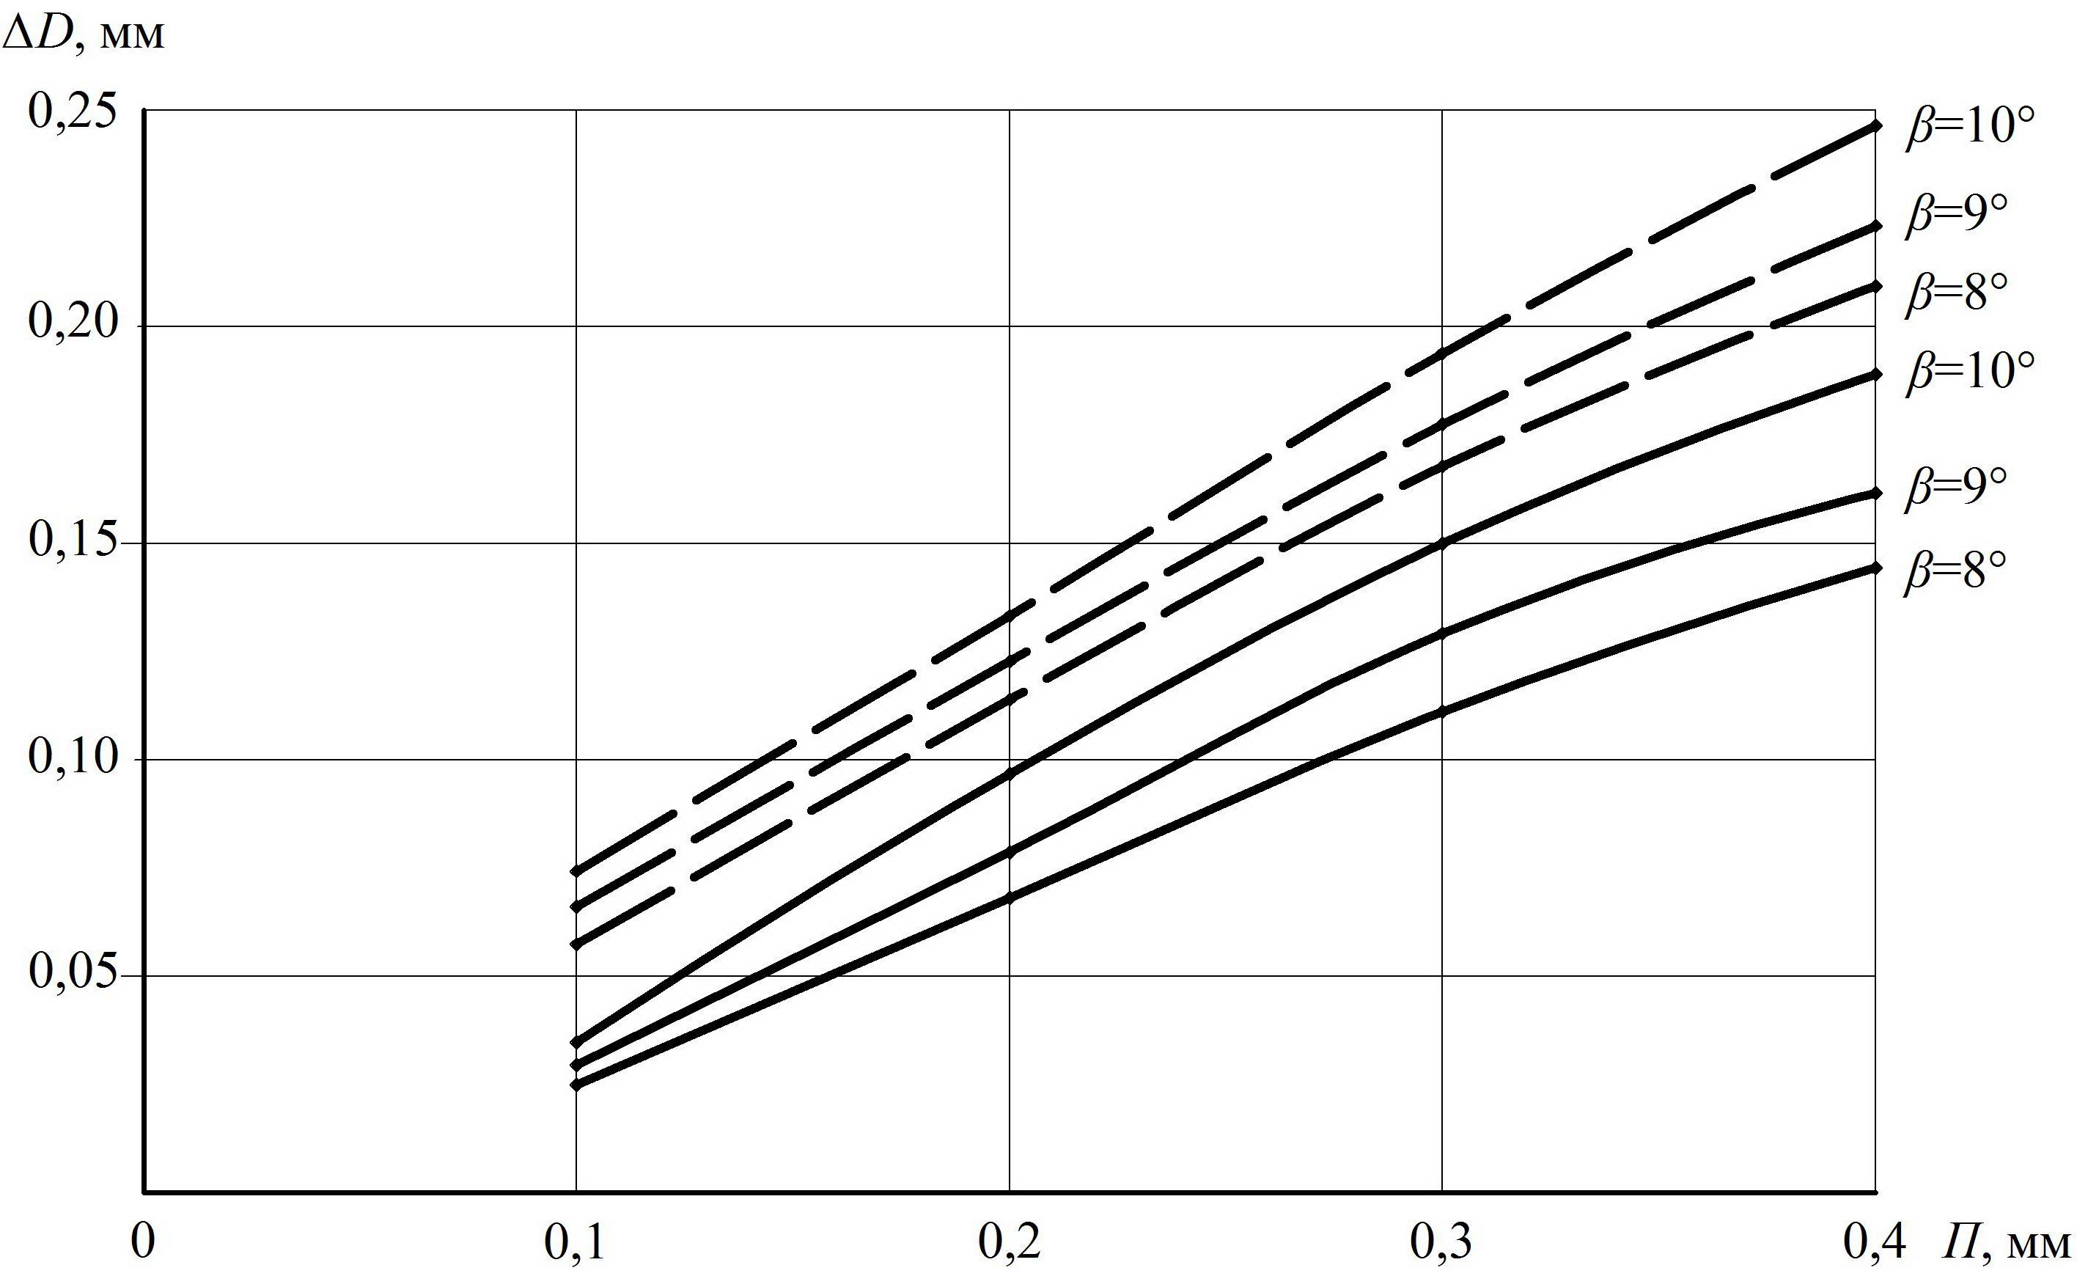
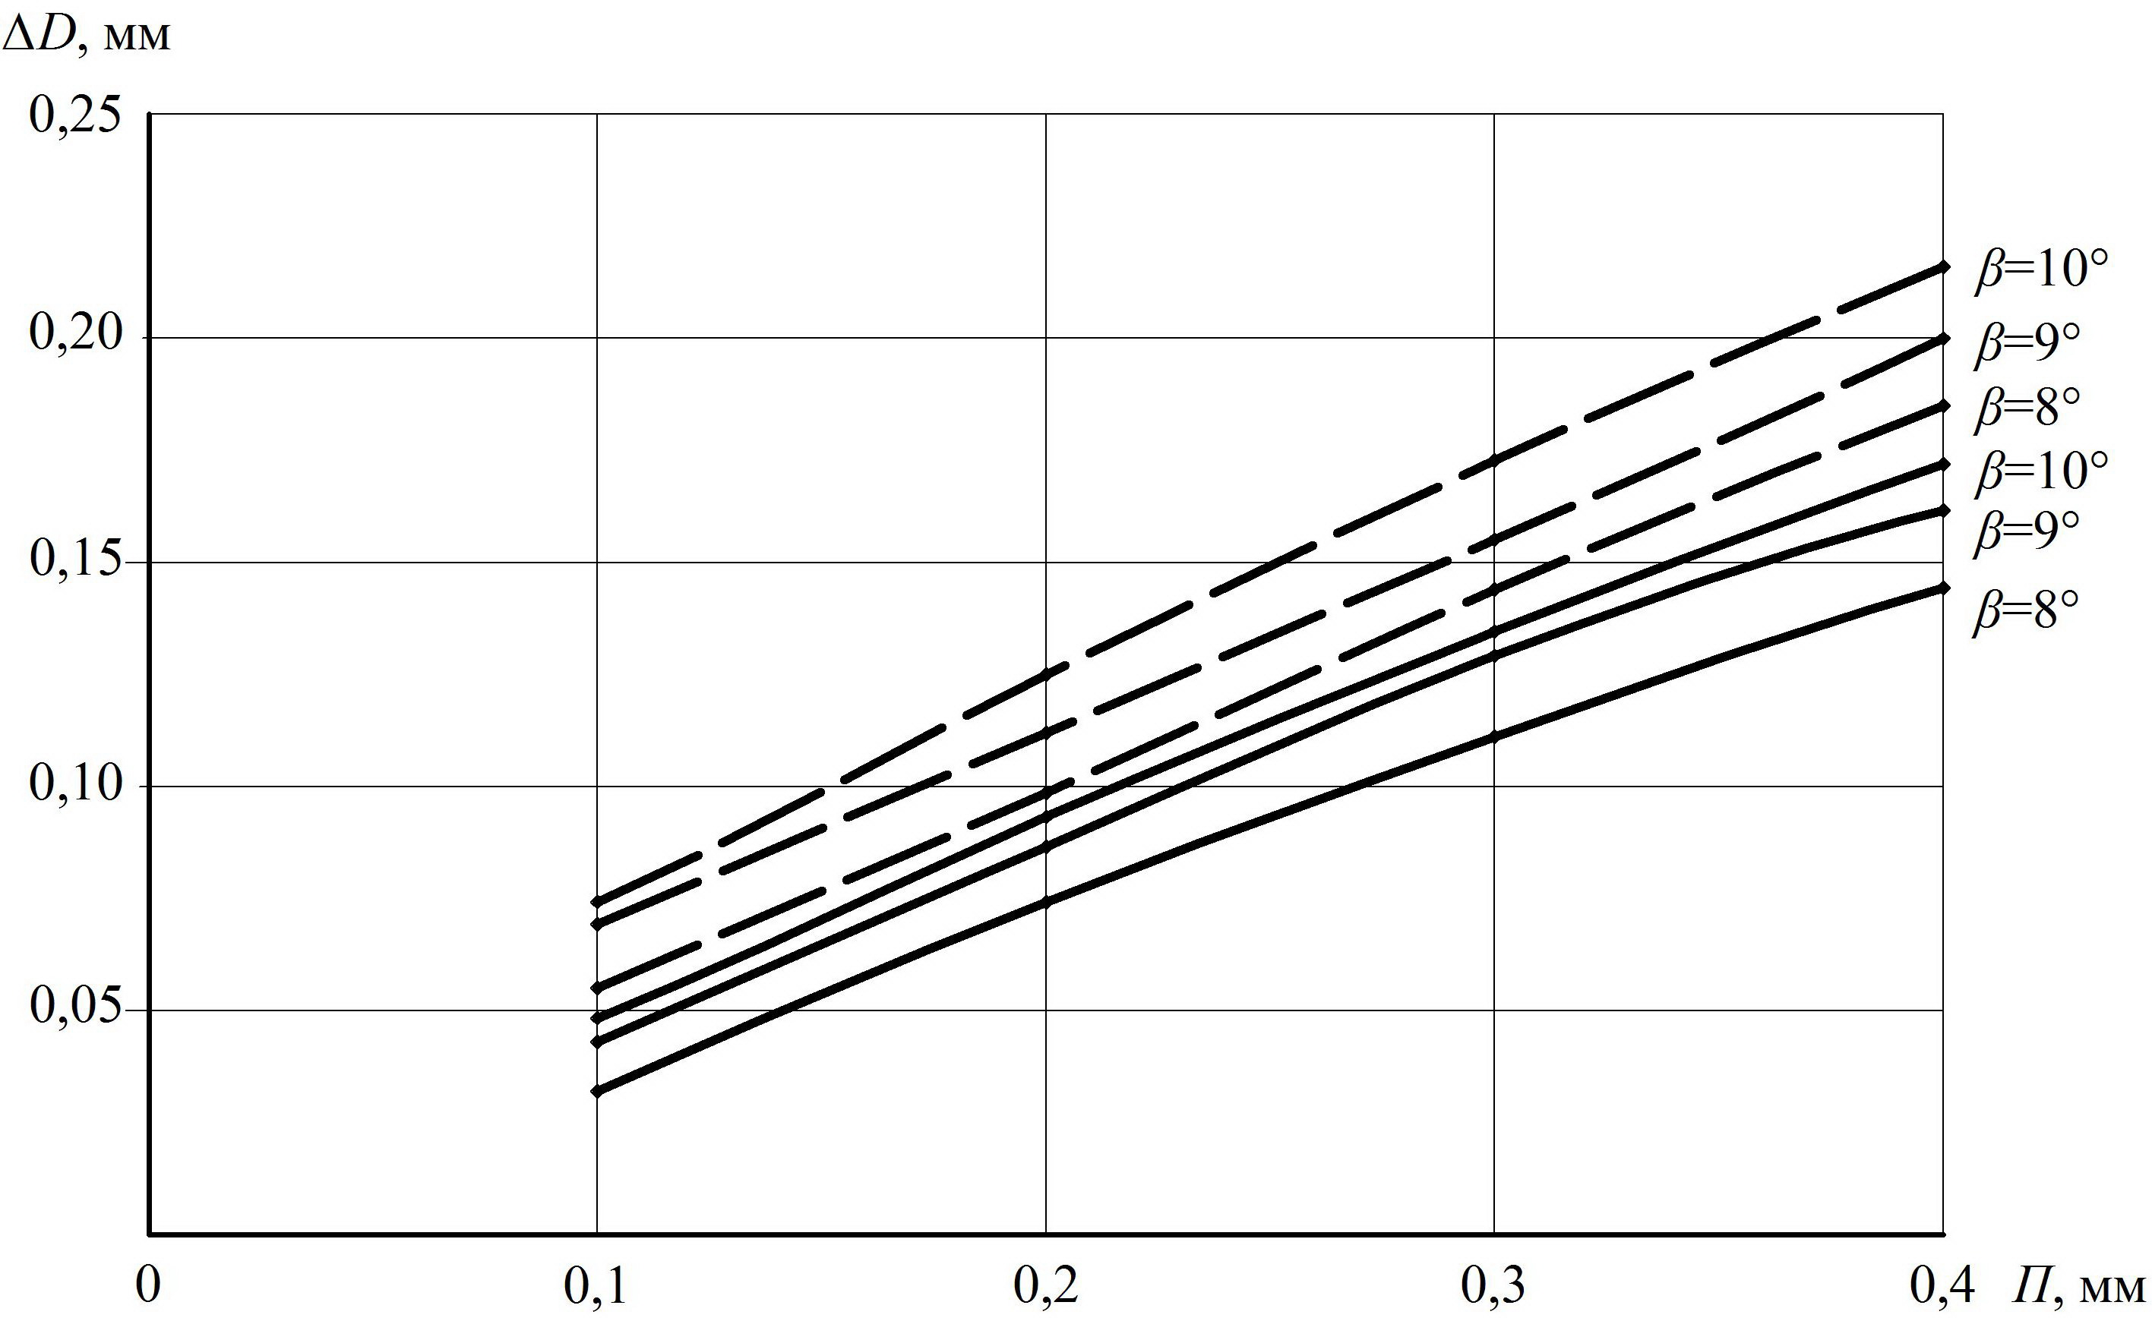

Fig. 3. Change of the outer diameter of the lower belt of the sample: during normal distribution; during vibrational deformation
Fig. 4. Change of the outer diameter of the upper belt of the sample: during normal distribution; during vibrational deformation

As can be seen from the graphs, the nature of the change in the outer diameter of the upper and lower belts of the samples under normal and vibrational deformation conditions is identical. With processing allowances of 0.1...0.3 mm, the change in the outer diameter occurs according to a dependence close to a straight line. However, with vibration deformation, the increase in the outer diameter is more important than with normal deformation.
Thus, with an allowance of mm, the increase in the outer diameter of the upper belt of the sample at an angle of inclination of the punch of 9° was 0.200 mm during vibration deformation, and 0.158 mm during normal deformation.
As can be seen from the obtained data, the amount of deformation during vibration deformation is 1.26 times higher than during conventional processing.
In the conditions of vibrational deformation, a more uniform change in the outer diameter of the upper and lower belts of the bushings is observed. Thus, the increase in the outer diameter of the lower belt of the bushings when the angle of inclination of the punch was changed from 8° to 10° during normal deformation was 0.046 mm, and during vibration - 0.035 mm.
This indicates a more uniform course of deformation in the radial direction during vibration deformation compared to normal.
The coefficient of deformation along the outer diameter of the upper belt during vibration deformation at the angle of inclination of the punch was:
,
and with normal deformation, respectively
.
Together with the deformation of the bushing samples in the radial direction, their length changes depending on the allowance, the angle of inclination of the punch and the method of deformation.
The degree of deformation along the length of samples 38.5 mm long at the angle of inclination of the punch and mm allowance was 0.125 mm during normal deformation, and 0.068 mm during vibration, i.e. 45.6% higher.
Based on the obtained experimental data, it is possible to conclude:
1. During vibration deformation, the amount of deformation along the outer diameter is 1.26 times higher compared to normal deformation.
2. The degree of deformation of samples along their length during vibration deformation is 45.6% less than during normal deformation.
3. During vibrational deformation, more favorable conditions are created for a more uniform distribution of deformations throughout the volume of the deformed sleeve sample.
Literature
1. Mamalis, A., Grabchenko, A., Mitsyk, A., Fedorovich, V., Kundrak, J. (2014). Mathematical simulation of motion of working medium at finishing–grinding treatment in the oscillating reservoir. The International Journal of Advanced Manufacturing Technology, 70(1), 263–276.
2. Hamouda, K., Bournine, H., Tamarkin, M., Babichev, A., Saidi, D., Amrou, H. (2016). Effect of the Velocity of Rotation in the Process of Vibration Grinding on the Surface State. Materials Science, 52, 216–221.

