Ivanenko Iryna Mykolaivna, PhD, associate professor
Igor Sikorsky Kyiv Polytechnic Institute, Kyiv
ORCID: 0000-0002-6885-3662
Fedenko Yurii Mykolaiovych, PhD
Igor Sikorsky Kyiv Polytechnic Institute, Kyiv
ORCID: 0000-0002-8599-1717

NANOSIZED ZINC OXIDE: PROPERTIES, PRODUCTION, APPLICATION

ZnO is a semiconductor of semiconductor group II-VI. It has the crystal structure of wurtzite (hexagonal symmetry), zinc mixtures, or rock salt (cubic symmetry), as shown in Fig. 1. However, ZnO crystals are most often stabilized in the wurtzite structure by a hexagonal unit cell (space group P63mc). The crystals exhibit the rock salt phase only at high pressures.

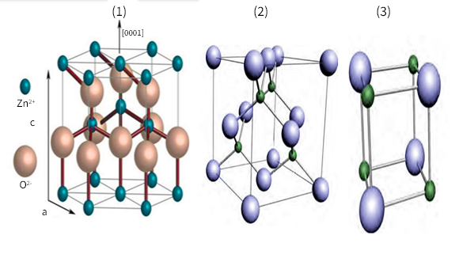
Fig. 1. Different crystal structures of zinc oxide (1) wurtzite, (2) zinc mixture and (3) rock salt

The structure of ZnO of the Wurtzite type can be considered to consist of two interpenetrating hexagonal tightly packed (hcp) sublattices of cation (Zn) and anion (O), shifted by the length of the cation-anion bond in the direction c. The lattice constants of the hexagonal unit cell of ZnO are a = 3.2500 Å and c = 5.2060 Å at 300 K. The c/a ratio for ZnO is 1.60, which is close to the ratio of 1.633 of an ideal hexagonal densely packed structure. Each hexagonal close packing (hcp) consists of one type of atom moved relative to each other along the triple axis c by u=3/8=0.375 in fractional coordinates (the parameter u is defined as the length of the bond parallel to the c axis in units of c or the distance of the nearest neighbor b divided by c). α and β are the bond angle 109.070, as shown in Fig. 2.

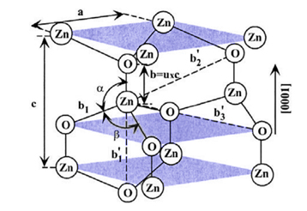
Fig. 2. Schematic diagram of the wurtzite structure of ZnO [1]

Production of nanosized zinc oxide. There are two main methods used in the synthesis and production of ZnO nanostructures. These techniques are called top-down and bottom-up. The top-down technique refers to a fabrication technique whereby an object is created by carefully removing pieces of a larger object, essentially carving out the desired object. In this technique, it starts with a bulk material and is then broken down into smaller pieces using mechanical, chemical, or other form of energy. The top-down approach often uses traditional workshop or micro-manufacturing methods, where externally controlled tools are used to cut, mill, and shape materials into the desired shape and order. A key advantage of the top-down approach is that parts are molded to a pattern and assembled on-site, so no assembly is required. The bottom-up approach, or sometimes referred to as the self-assembly approach, used chemical or physical forces acting at the nanoscale to assemble basic units into larger structures. In contrast to the top-down technique, the bottom-up technique starts with small structures and ends with large units [2].
Application of zinc oxide. ZnO is a very important material, and it has attracted intense research efforts due to its unique interesting properties such as anisotropy in the crystal structure, non-stoichiometric defect structures, high exciton binding energy, wide band gap, optical transparency in visible light, high refractive indices, large piezoelectric constants, and nonlinear optical coefficient. Due to these new properties, ZnO has been used for acoustic-wave devices, gas sensors, piezoelectric transducers, light-emitting diodes (LEDs), and laser diodes (LDs) of transparent electrodes [40]. In fact, the predominant material for blue or UV-emitting diodes (LEDs) is gallium nitride (GaN). However, ZnO nanostructures are promising candidates for nanoelectronic and nanophotonic devices.
ZnO has several fundamental advantages over GaN; its free exciton (60 meV) is much higher than that of GaN (21‒25 meV) and it has high energy resistance to radiation, making it a suitable candidate for space applications. It is more amenable to wet chemical etching and can be grown in a natural substrate. Lighting (where white light is obtained from phosphors excited by blue or UV-emitting diodes), secure communications, and biodetection [3].
In addition, zinc oxide has been used for various technical purposes, including porcelain enamels, heat-resistant glass, vulcanization activator, additive to rubber and plastics, pigment in paints with UV protective and fungal static properties, protective coatings for spacecraft, part of cigarette filters, healing ointments, and in
optical waveguides.

Literature
- Fokotsa V., Lehlohonolo F. Phase formation of hexagonal wurtzite ZnO through decomposition of Zn(OH)₂ at various growth temperatures using CBD method. Optical Materials. 2015. Vol. 46. P. 292‒298.
- Raoufi D., Raoufi T. The effect of heat treatment on the physical properties of sol–gel derived ZnO thin films. Applied Surface Science. 2009. Vol. 255, No 11. P. 5812‒5817.
- Omri K., Najeh I., Dhahri R. Effects of temperature on the optical and electrical properties of ZnO nanoparticles synthesized by sol–gel method. Microelectronic Engineering. 2014. Vol. 128. P. 53‒58.

