Wei Chencheng
West Ukrainian National University, Ternopil
Grygoriy Hladiy, PhD
West Ukrainian National University, Ternopil
ORCID 0000-0002-5585-8472

COMMUNICATION MODEL OF DISTRIBUTED PROJECT TEAM MANAGEMENT

A new modern challenge associated with the development of technologies is the management of projects in the conditions of globalization and pandemic. Most project work today is carried out in a distributed manner under the conditions of different time zones, cultural differences and lack of personal communication. Since work in different time zones of the globe takes place on a 24/7 model, team management and factors influencing the effectiveness of interaction between team members are critically important, so the perspectives of research in the field of project management are related to distributed teams.
The methodology and management tools are the basis of the work of the distributed project team. The distributed team management process model is based on a flexible project management methodology, and each tool takes its important place in organizing work processes for a remote team. Flexibility and maneuverability in work are extremely important for such a team, because the quality of the project the team is working on depends on it. Each member of the team must have a clear understanding of how the work on the unit (task) is structured, into which the work on the project is divided.
When working on a large complex project, the latter is usually divided into separate tasks, which are often interconnected. Direct work according to this model for a distributed team can be described on the example of the process of the team performing a specific task. The scheme of work on the task in a distributed team can be presented in Fig. 1.

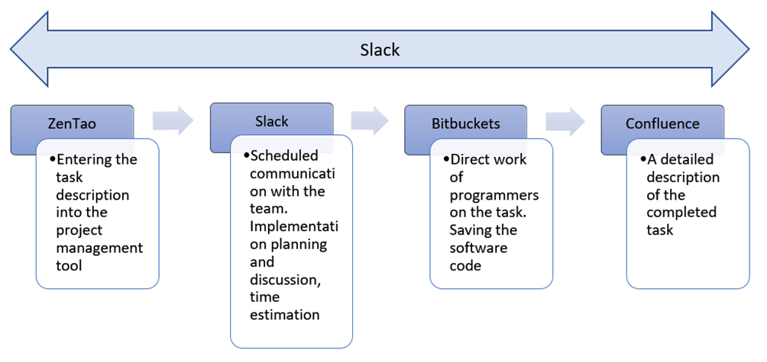
Figure 1 – Distributed project management model (in terms of communication tools)

When the general goal (idea) is implemented through specifically formulated tasks, they are distributed in the team. That is, the team has to work with a specific task, turn it into the existing functionality of the project. To do this, the team manager must issue this task in the system, which is used to record, manage and directly store all tasks and errors on this project.Project management is a large and deep field of research. This article mainly analyzed and studied such issues for the lathe virtual simulation system as software development schedule management, project resource provisioning and risk management.
In China, the most common tool for this is ZenTao [1], which successfully competes with the well-known Jira project management software [2]. With its help, the project manager and other team members can track and change the status of the task, add comments, make links to documentation, etc. When a card with a corresponding task is created for the team in ZenTao, that is, team members can view the task, the transition to the next stage of working with this task takes place.
After creating a task in the ZenTao management tool, it must be discussed with the team live, for example, in the process of planning the scope of work for the next development cycle. Then there is a general video meeting of the entire development and testing department, where team members discuss requirements, implementation methods and give an approximate estimate of the time required to implement the task.
The universal corporate messenger Slack [3] is mostly chosen as a tool for conducting video meetings.
Further, specific developers begin to work on this task. To work on it, the programmer uses the Bitbucket tool [4]. In it, his code is checked by other developers in order to detect possible errors or to resolve controversial points. The software code itself is stored in Bitbucket.
When a task is fully completed, running without errors, and complete, it should be documented. This applies to both technical and business documentation. If any changes are made to the functionality of this task, then these changes must also be made in the documents. For this, a service for storing documentation – Confluence [5] is used.
Throughout the duration of the project, there is also a constant need for an instant communication tool, namely the Slack software, to be able to contact any team member or all of them at once.
The indicated scheme of using communication tools can be supplemented with other tools if necessary.

References
- Official site of the ZenTao. URL: https://www.zentao.pm.
- Jira Software. URL: https://www.atlassian.com/software/jira.
- Official site of the Slack Technologies. URL: https://slack.com
- Official site of the Bitbucket. URL: https://bitbucket.org
- Confluence Software. URL: https://www.atlassian.com/software/confluence.

