Zhang Yibao
West Ukrainian National University, Ternopil
Grygoriy Hladiy, PhD
West Ukrainian National University, Ternopil
ORCID 0000-0002-5585-8472

Project management of General Lathe Virtual Simulation teaching system

Traditional metalworking training is faced with problems such as lack of places and equipment, lack of teaching staff, auxiliary staff and safety supervisors, short teaching time and traditional teaching methods, and students are prone to safety accidents in the operation process. Students also lack an understanding of the internal structure of the lathe and the movement mode of the equipment. The virtual simulation learning system will be used to show the basic structure of the lathe, the internal operation mode and the movement process of processing in front of the students, and can deal with the relevant problems. Moreover, students are allowed to simulate virtual assembly of relevant parts and experience the operation process of the lathe, and more students are allowed to repeat virtual turning exercises before the practical training of the turners, so as to ensure the safety in the actual operation [1]. In addition, theoretical learning can be tested through the evaluation of theoretical topics in the system to improve the learning efficiency of turning [2].
1. The development of the project schedule
The progress plan is the most important task in the development of the virtual simulation teaching system of the general lathe. According to the scientific and effective management of the project, and the reasonable project schedule and arrangement, the project team can coordinate, plan and use the resources of the project to ensure the normal development and development of the project. After the paper determined that the virtual simulation teaching system of the common lathe was determined, the plan was used to manage the project's progress, and the method was mainly with WBS, Gantt, plan review technology and key path method, and the tools used were MS Excel.
2. Use the work breakdown structure to refine project activities
It is the core content of project schedule management to establish the work structure breakdown of the project. The whole project is divided into each single and independent sub-unit, and the project responsibility is decomposed well at the same time, the work task activities of the whole project are decomposed to each member of the project team, the responsibility of the project work is quantified as far as possible, and the project work and the responsible person are publicized. Before the software development of general lathe virtual simulation teaching system, we should first develop and plan the work plan of the whole software project, and effectively decompose the activities of the project into a work package, which is helpful to do a good job of project time estimation, arrangement and monitoring management.
After confirming the detailed requirements of the general lathe virtual simulation teaching system, the project team adopted the WBS method to take the development task of the software project as the general task. Through the division of the software life cycle, the sub-tasks of the project were decomposed step by step from the requirements, design, implementation, testing and other stages. On this basis, the project team first analyzed and evaluated the development work of the virtual simulation teaching system software of the common lathe, and then decomposed the project software development work reasonably by using the WBS method. The software decomposition structure of the virtual simulation teaching system of the common lathe is shown in Figure 1.
3. Project calendar schedule
According to the development cycle of the software project, make the project schedule, and draw the Gantt chart corresponding to the project by using the chart tool of Excel software, so as to clearly describe the planning of the whole project in the form of Gantt chart. General lathe virtual simulation teaching system development Gantt diagram, as shown in Figure 2.

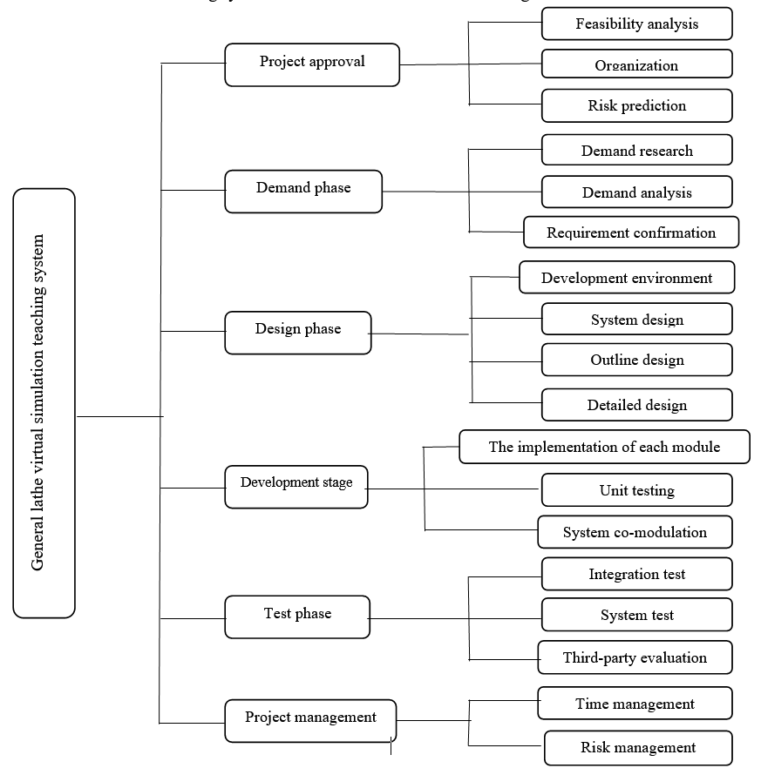
Figure 1. General lathe virtual simulation teaching system diagram

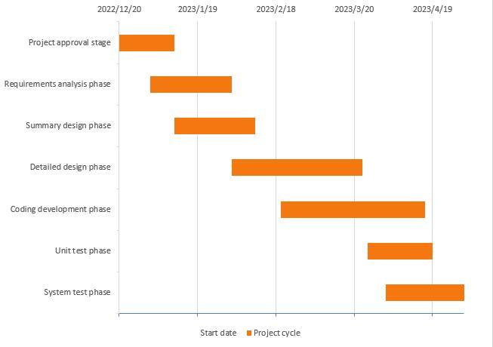
Figure 2. Gantt diagram of project software development
The approval of the whole project started in mid-December, and it took more than half a month to verify the feasibility of the research and development project through theories, technologies and schemes. After passing the team review, we formulated the organizational structure and carried out the demand analysis phase of the project in parallel. After the general demand module and framework were formed, we further started the outline design and detailed design work of the system in parallel. Since it was the end of the semester and the Spring Festival holiday was very urgent, we should coordinate the resources and manpower of the project at the right time during the completion of each activity and start the next stage of the activity. The basic project approval, requirements and design were completed in the first two months. The core coding development process was scheduled in February, March and April. After the development of the main core modules was completed, unit testing would be carried out first, and the final system test would be arranged in April.
General lathe virtual simulation system is a project created and customized for metalworking practical training students of ordinary colleges and universities in combination with their own needs. Due to the urgent requirement of research and development time, it is necessary to determine the management methods and relevant measures of the project.
4. Resources required for project implementation
The project resource requirement plan refers to the plan that analyzes and plans various resources required by the project, and tracks and manages them during the project execution. The preparation of project resource demand plan can help project managers predict and coordinate the utilization of resources in the process of project implementation, ensure the sufficient supply of project resources, and improve the quality of project execution efficiency.
5. Project risk management
The general lathe virtual simulation teaching system uses Boehm model, Delphi method, brainstorming method and risk check list to establish the project risk list effectively. The detailed process is as follows: the first step is to make a good plan and design the Delphi questionnaire of the project, which is mainly to analyze and evaluate the risks that may arise at each stage of the project of virtual simulation teaching system of common lathe. The second step is to sort out all the risks collected, and then hold a workshop within the project team to brainstorm and discuss the results of the collected questionnaire. This process will be carried out at least two or three times to ensure the accuracy and comprehensiveness of the survey results of the risk list. The project manager will eventually compile the results of the meeting and come up with a list of project risks. According to the theory of risk assessment and the brainstorming method, the project manager and the whole project team discussed and scored the degree of risk impact and the probability of risk occurrence of the individual soldier command communication system in detail, and obtained the degree of risk through mathematical calculation.
In the whole development cycle of the general lathe virtual simulation teaching system, the project team will hold internal meetings regularly to review and evaluate the existing risk status at the present stage, and adjust, modify and update the risk list to make effective countermeasures in time.
Conclusions
Project management is a large and deep field of research. This article mainly analyzed and studied such issues for the lathe virtual simulation system as software development schedule management, project resource provisioning and risk management.

References
Zhao Xinwei, Ao Jian, Zhang Junmin, Zhao Ziyun. Research on Metalworking practice Course based on Virtual Simulation Technology. Laboratory Science and Technology of Universities. 2019. Vol.3. P.50-51.
He Jianfei, Zheng Dingke, Zhang Guwu, Wen Wei. Application of Virtual Simulation Technology in metalworking practice. Education and Teaching Forum. 2012. Vol.21. P.153-155.

