Gorodetskyi Viktor assoc. prof., PhD, ORCID 0000-0003-4642-3060
Dubovyk Volodymyr senior lecturer, ORCID 0000-0001-8884-8222
Polishchuk Valentyna senior lecturer, ORCID 0000-0001-9116-7962
Bushtruk Yevheniia student, ORCID 0009-0003-9864-5543
National Technical University of Ukraine “Igor Sikorsky Kyiv Polytechnic Institute“

PUMP UNIT CONTROL USING PERFORMANCE SENSORS
One of the important requirements for a pump unit is the use of pumps in modes corresponding to their nominal parameters. The deviation of the operating modes of the pump from the nominal values entails a decrease in efficiency and, as a result, an excessive consumption of electricity. The use of a pump outside the working area not only significantly degrades its efficiency, but can also cause the pumps to go into an unacceptable operating mode.
The block diagram of the automatic control system (ACS) of a pumping unit with an adjustable electric drive is shown in fig. 1.
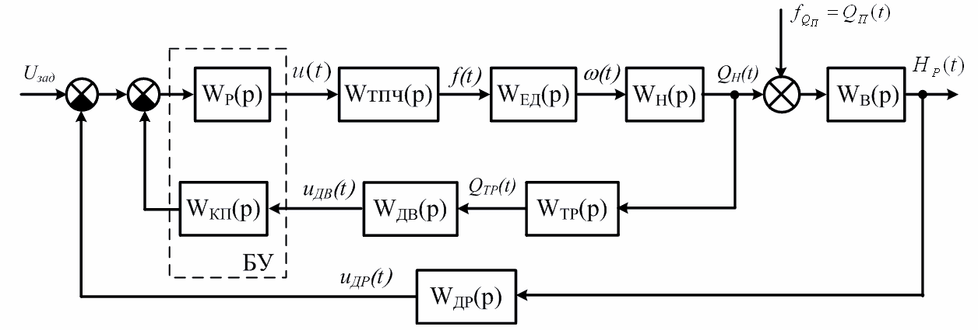
Figure 1 - Structural diagram of the ACS pumping unit
On fig. 1, the following designations are used: Wp(р) - transfer function of the control unit; transfer function of the pump W_{н}(p)=k_{н}/(T_{н}p+1), where k_{н}=Q_{н}^{ном}/ω^{ном}; Q_{н}^{ном} - nominal flow of the pump, м³/h; ω^{ном} - nominal angular velocity of the impeller, rad/s; W_{тпч}(p)=k_{тпч} is the transfer function of the transducer; W_{ду}(p)=k_{ду} – transfer function of the level sensor. To control the pumping unit, a device is proposed, fig. 2. It consists of a level sensor 1, to the output of which three threshold elements 2, 3, 4 are connected, the second inputs of which are connected to sources E1, E2, E3 of a constant input action, and the outputs of the first 2 and second 3 threshold elements are connected, respectively, with the first 5 and second 6 elements NAND and also, respectively, with the R input of the first R-S trigger 7 and the R input of the second R-S trigger 8, and the S input of the first R-S trigger 7 through the first element NAND 5 is connected with the output of the second threshold element 3, and S the input of the second R-S trigger 8 through the second element NAND 6 is connected to the output of the third threshold element 4, the output of the first R-S trigger 7 is connected to the input of the electronic key 9, the second input of which is connected to the second inputs electronic keys 10 and 11 and power source E4 of magnetic starters 12, 13, 14, which are connected by inputs, respectively, to the outputs of electronic keys 10, 11 and 12, the outputs of performance sensors 15 and 16 are connected, respectively, through the third 17, fourth 18 elements NAND with inputs of the first 19, second 20 elements AND, the second input of the first element AND 19 is connected to the output of the first R-S trigger 7, the second input of the second element AND 20 is connected to the output of the second R-S trigger 8, the outputs of the first 19 and second 20 elements AND are connected to the inputs of the OR element 21, the output of which is connected to the input of the third electronic key 11.
Through magnetic starters 12, 13, 14, the supply voltage is supplied to the electric motors of the pumps of the upper, emergency and reserve levels, which in fig. 1 are not shown [1]. During operation of the device, sources of constant input action are used: E1 - lower level, E2 - upper level and E3 - emergency level. When the water level rises to the value of the lower level, the level of a logical unit appears at the output of the threshold element 2, the state of the R-S trigger 7 does not change, U₇ = 0, the level of the logical unit is set at the input of the NAND element 5. When the water level rises to the upper level, a logic unit level appears at the output of the threshold element 3, the R-S trigger 7 switches, since, from the output of the NAND element 5, a zero logic level is supplied to the S input of the R-S trigger 7 and the logic one level is applied to electronic key 9, which switches and supplies power to the source E4 to the magnetic starter 12, and this provides power to the upper-level pump motor.
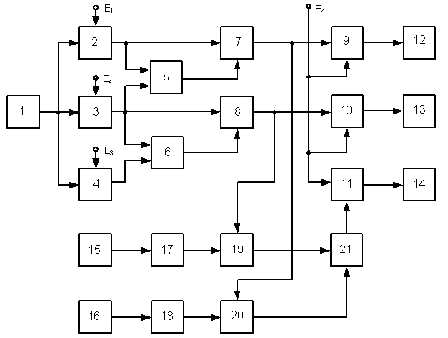
Figure 2 - Structural diagram of the pump unit control device

The upper-level pump provides operating performance and a logical unit signal appears at the output of the performance sensor 15. This signal is fed to the NAND element 17, from the output of which the logical zero signal is fed further to the input of the AND element 19, which blocks the signal from the R-S trigger 7 through OR element 18 to electronic key 11.The water level in the sump decreases, and first the signal at the output of the threshold element 3 switches to zero, which does not cause changes in the operation of the switched on pump. Further, at the output of the threshold element 2, the signal switches to zero, which leads to switching of the R-S trigger 7, the output logical zero of which is fed to the electronic key 9, which opens and turns off the power to the magnetic starter 12 and to the electric motor of the upper level pump.
Economic efficiency in the automation of pumping units is achieved by reducing maintenance personnel, reducing power consumption by eliminating the operation of pumps idle, reducing their start-up time, the total number of starts and reducing emergency situations.
References:
1. Патент Украины на полезную модель №66712. Дубовик В.Г., Лебедев Л.Н., Мишурняев Д.О. Устройство управления насосной установкой. МПК F04D 15/00. Опубл. 10.01.2012, Бюл. №1.

