Cherepanov Illia, PhD student
National Aerospace University “Kharkiv Aviation Institute”
SELECTION OF NO-REFERENCE QUALITY METRICS FOR METHODS OF THRESHOLD SELECTION FOR DCT-SSA FILTER
Synthetic aperture radars (SARs) are used to acquire images that are employed for a variety of practical applications, from analyzing soil and vegetation cover to searching for large accumulations of illegally dumped debris. The problem of processing such images is that they are corrupted by speckle - a noise-like effect with multiplicative nature. Also, speckle might have a non-Gaussian distribution and be spatially correlated. To address this problem, many filters have been developed that take into account the non-Gaussianity of the distribution and provide acceptable speckle suppression. Discrete Cosine Transform (DCT) based filters or BM3D filters are examples of such despeckling techniques [1]. A common problem with most filters remains that they distort low-size details, edges of large-size objects and textures, resulting in an undesirable blurring effect.
This problem was addressed in [2] by splitting the DCT-based filtering into four stages: in the first stage, a two-dimensional DCT is performed in each block; in the second stage, thresholding is applied, for example, according to a predefined scheme; in the third stage, an inverse DCT is performed to obtain filtered values for each pixel of the block; and at the fourth stage, aggregation of the filtered values for each pixel is performed if block overlapping is used. In the discussed method, frequency dependent thresholds are set proportional to average value within a given block or some analog of the local average:
$$T(n,m, k, l)=βσ_{μ}\overline{I}(n,m)\sqrt{W(k,l)}$$ | (1)
where β is the parameter controlling the filter properties, it is usually set approximately equal to 2,7; $\overline{I}(n,m)$ denotes the local mean (or its analog) for the image block with the upper left corner in the pixel with indices n, m; $σ_{μ}^{2}$ is the relative variance of multiplicative noise (speckle); $W(k,l)$ denotes the normalized power DCT spectrum. If a DCT coefficient $D(n,m, k, l)$ is greater than or equal to $T(n,m, k, l)$, it remains unchanged; otherwise, it is set to zero.
However, even within this method, a loss or smearing of bright points and small objects of 5–15 pixels in size was observed. There was also an issue of excessive smoothing for blocks capturing the edges of objects.
In [3], a modification of this method was proposed, in which the calculation of the local mean was replaced with the calculation of the median or the minimal interquartile distance. By varying the β parameter, we achieved the results presented in Figures 1 and 2. For quantitative quality assessment, the conventional reference-based metrics PSNR and PSNR-HVS-M were used as well as the less common Haar-PSI metric, which takes into account visual salience, was employed.
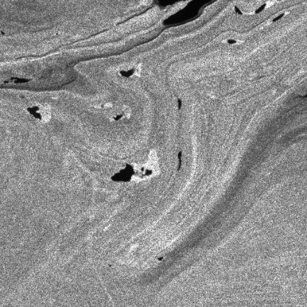 | 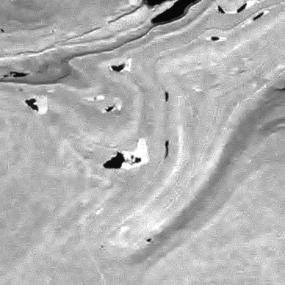
a) | b)
Fig.1 Noisy and optimally filtered image
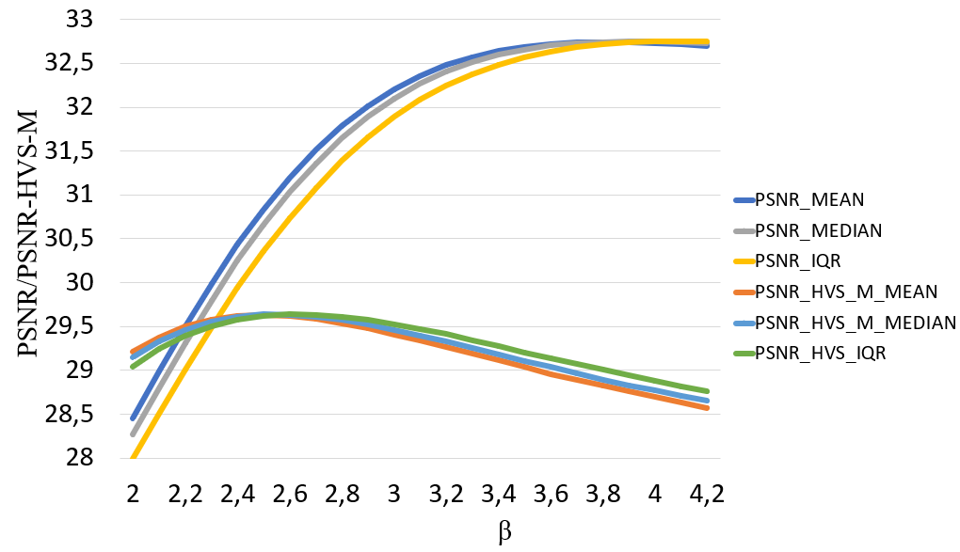 | 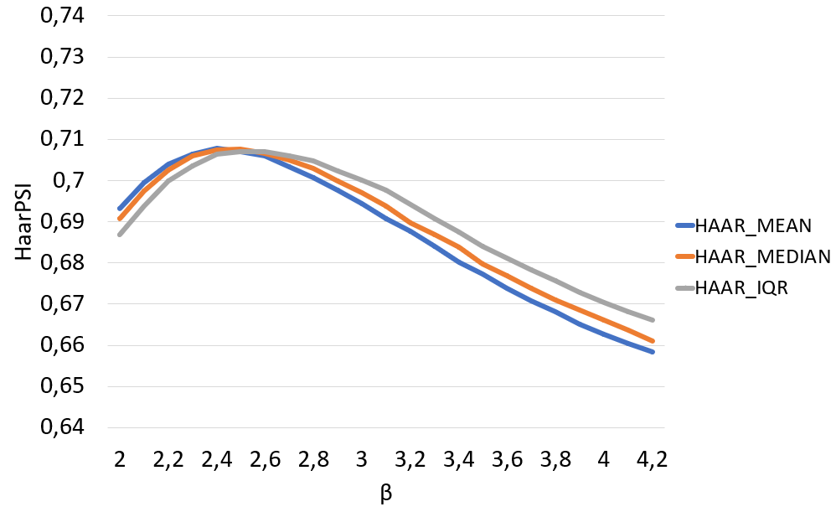
а) | b)
Fig. 2 - Plots of dependences of metrics values on β
The plots demonstrate that for metrics incorporating the human visual system (Haar-PSI and PSNR-HVS-M), each modification of the DCT filter exhibits optimal β values that differ from 2.7.
It was also established in [3] that replacing the statistical parameter used to calculate the threshold value for the DCT-SSA filter results in a slight improvement in image quality at the output, which justifies the need for further exploration of an optimal statistical parameter.
However, a new challenge emerged. For quantitative quality assessment, we considered the simulated noise using the method proposed in [1]. Yet, in real SAR imaging, reference images are inherently unavailable. So, it is impossible to calculate the full-reference metrics and find the optimal β. To address this limitation and enable analysis of real-world data, we focused on searching adequate metrics that do not need noise-free references — commonly referred to as no-reference metrics.
For these purposes, we selected four widely used no-reference quality metrics: Sharpness Laplacian and Sharpness Tenengrad (the higher the value the better), PIQE, and NIQE (the lower the value the better). Using these metrics, we analyzed the noisy images obtained in [3]. The results obtained by varying the β parameter are presented in Figures 3 and 4.

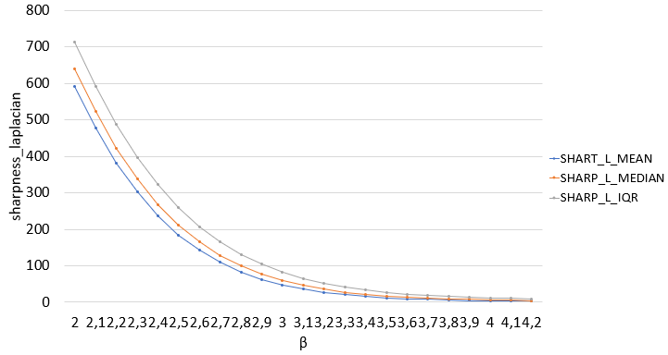 | 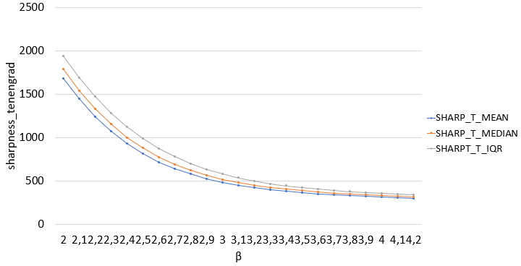
а) | b)
Fig. 3 - Plots of dependences of Sharpness L (a) and Sharpness T (b) quality metrics values on β
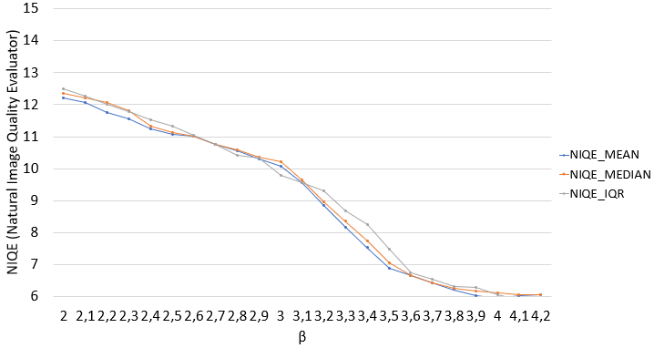 | 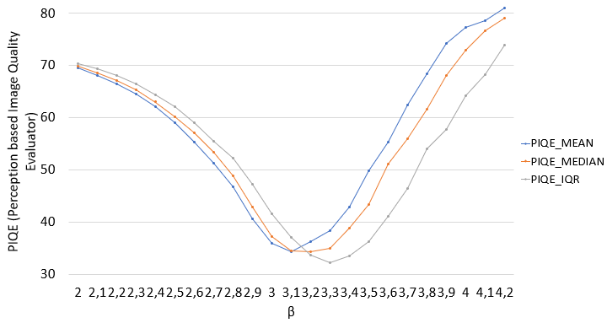
а) | b)
Fig. 4 – Plots dependences of NIQE (a) and PIQE (b) quality metrics values on β
Based on the obtained plots, we can conclude that the Sharpness Laplacian and Sharpness Tenengrad metrics show a consistent decrease in quality with increasing β values. On the contrary, NIQE, similar to PSNR, shows a consistent improvement in quality, which does not align with the results of PSNR-HVS-M and HaarPSI. However, for the PIQE metric, the optimal value appears at β = 3-3.3, similar to HaarPSI and PSNR-HVS-M.
From these results, it follows that PIQE can be potentially used as the no-reference quality metric to evaluate filtered images in future work aimed at providing the optimal performance of the DCT-SSA filter.
References
1. O. Rubel, V. Lukin, K. Egiazarian, “Additive Spatially Correlated Noise Suppression by Robust Block Matching and Adaptive 3D Filtering,” Journal of Imaging Science and Technology, October, 2018, pp. 12.
2. O. Rubel, V. Lukin, S. Krivenko, V. Pavlikov, S. Zhyla, E. Tserne, “Reduction of Spatially Correlated Speckle in Textured SAR Images,” International Journal of Computing, September 30, 2021, pp. 9.
3. I. Cherepanov, "INVESTIGATION OF DIFFERENT METHODS OF THRESHOLD SELECTION FOR DCT-SSA FILTER", Herald of Khmelnytskyi National University Technical sciences, March, 2025, pp. 458-465.

